
INDUSTRY REPORT N79.110
Travel Agencies in the UK
Needing a break: The industry is likely to suffer while some countries require travellers to self-isolate
Alice Crundwell | October 2020



Contents

COVID-19 (Coronavirus) Impact Update 3
About This Industry 5
Industry Definition 5
Major Players 5
Main Activities 5
Supply Chain 6
Industry at a Glance 7
Executive Summary 9
Industry Performance 10
Key External Drivers 10
Current Performance 11
Industry Outlook 14
Outlook 14
Industry Life Cycle 16
Products & Markets 17
Supply Chain 17
Products & Services 17
Major Markets 18
Business Locations 19
Competitive Landscape 22
Market Share Concentration 22
Key Success Factors 22
Cost Structure Benchmarks 23
Basis of Competition 25
Barriers to Entry 26
Industry Globalization 27
Major Companies 29
Major Players 29
Other Companies 32
Operating Conditions 33
Capital Intensity 33
Technology & Systems 34
Revenue Volatility 35
Regulation & Policy 36
Industry Assistance 36
Key Statistics 38
Industry Data 38
Annual Change 38
Key Ratios 38
Additional Resources 39
Additional Resources 39
Industry Jargon 39
Glossary 39

COVID-19 (Coronavirus)  Impact Update | IBISWorld's analysts constantly monitor the industry impacts of current events in real-time – here is an update of how this industry is likely to be impacted as a result of the global COVID-19 pandemic:  • Revenue for the Travel Agencies industry is anticipated to decline over 2020-21 due to falling demand amid global travel restrictions. For more detail, please see the Current Performance chapter.  • The coronavirus outbreak is expected to continue to take its toll on industry operators in the short run as some countries remain off the government's travel corridors list, requiring a 14-day quarantine period on arrival back in the United Kingdom. For more detail, please see the Industry Outlook chapter.  • Travel agents often purchase tours, flights and hotel rooms in bulk to be able to be sold on to customers at a slightly discounted price. Lower demand and cancelled itineraries are likely to weigh on profit over the next five-year period as firms attempt to sell tickets at discounted prices. For more detail, please see the Cost Structure Benchmarks chapter.

About IBISWorld
IBISWorld specializes in industry research with coverage on thousands of global industries. Our comprehensive data and in-depth analysis help businesses of all types gain quick and actionable insights on industries around the world. Busy professionals can spend less time researching and preparing for meetings, and more time focused on making strategic business decisions that benefit you, your company and your clients. We offer research on industries in the US, Canada, Australia, New Zealand, Germany, the UK, Ireland, China and Mexico, as well as industries that are truly global in nature.

About This Industry
Industry Definition | This industry is composed of agencies that provide booking, reservation and information services to UK residents travelling domestically and internationally. This includes agencies that are solely or partially online or shop-front operators. Operators generate their income from commissions.
Major Players | TUI Travel Ltd
Main Activities | The primary activities of this industry are:  Providing travel-related online booking services  Providing travel information  Making travel arrangements  Booking flights and accommodation  Selling travel packages  The major products and services in this industry are:  Travel agency services  Online booking services

Supply Chain
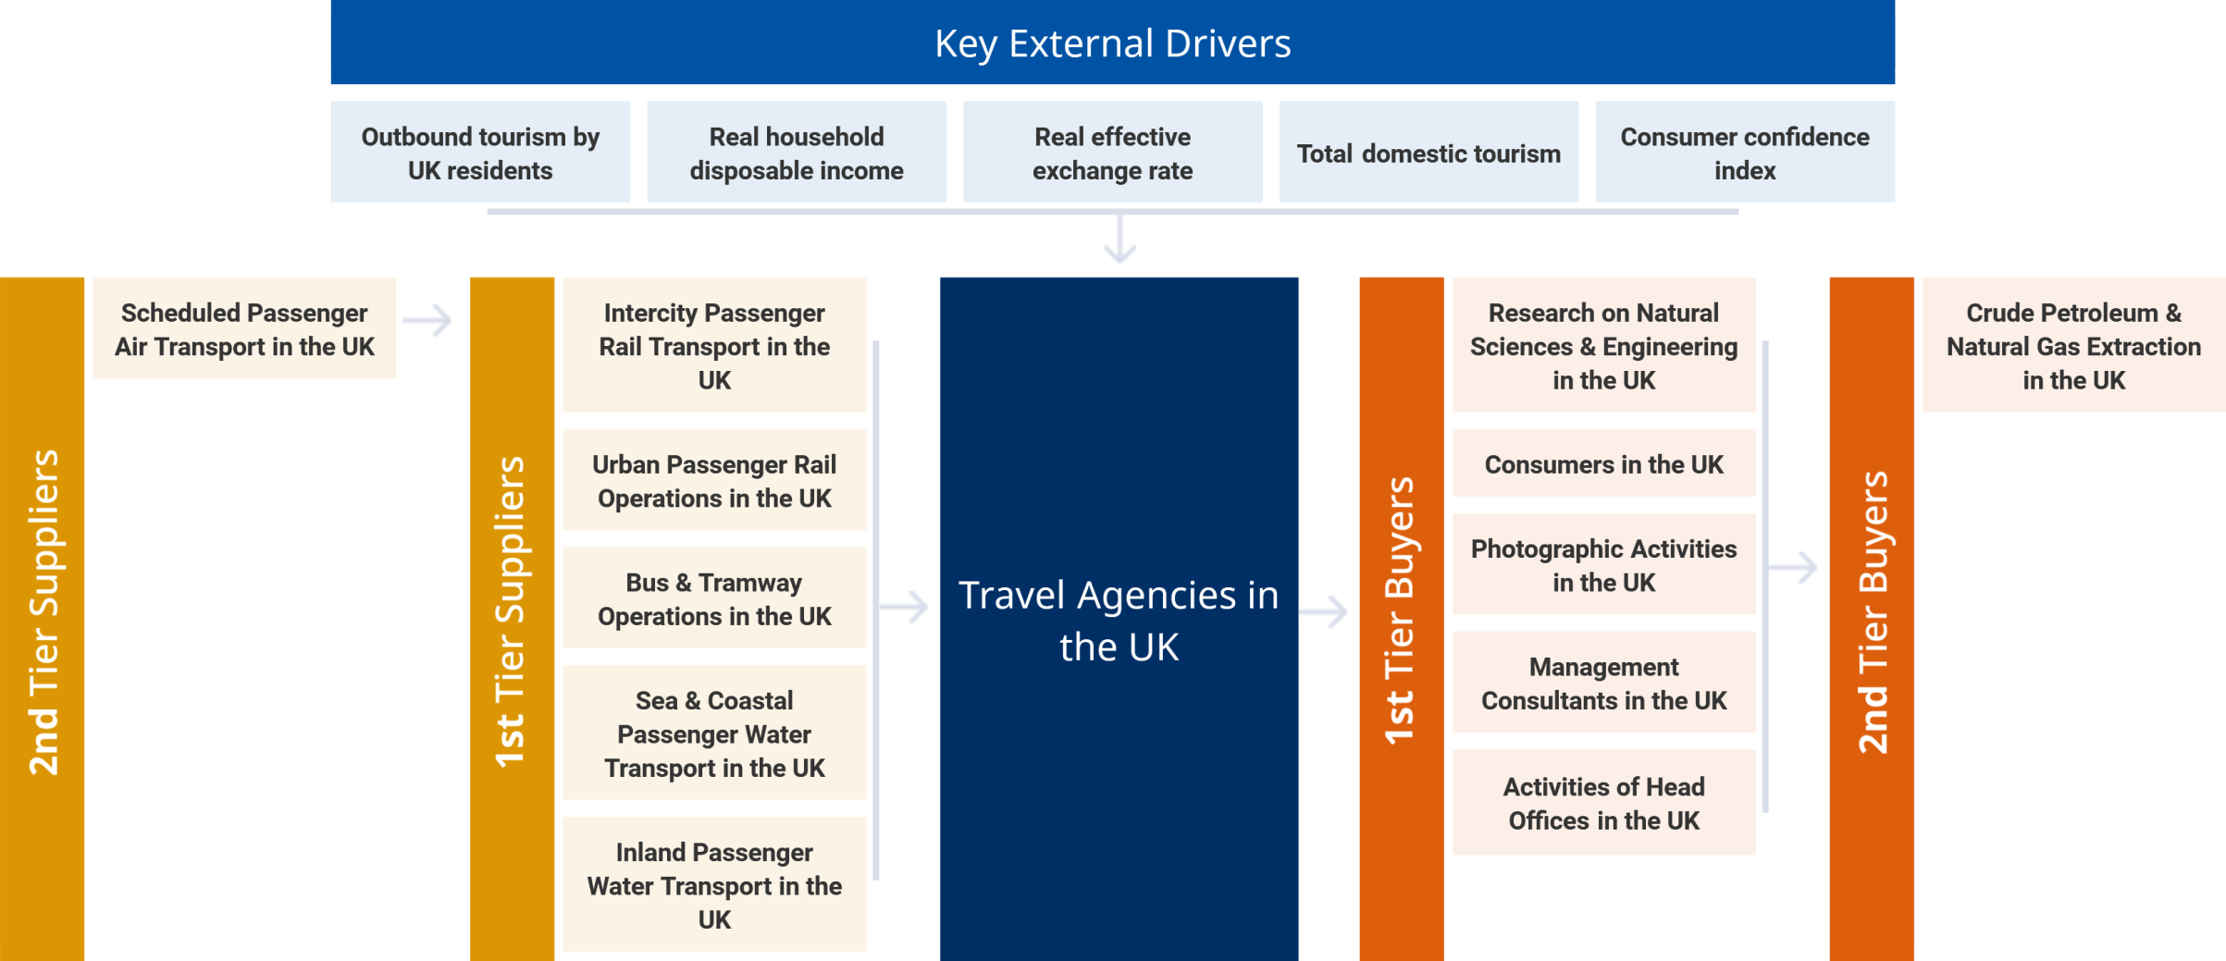

Similar Industries
Sea & Coastal Passenger Water Transport in the UK | Scheduled Passenger Air Transport in the UK | Non-Scheduled Passenger Air Transport in the UK | Tour Operators in the UK

Related International Industries
Global Travel Agency Services | Travel Agencies in the US | Cruise & Travel Agency Franchises | Travel Agency and Tour Arrangement Services in Australia
Travel Agencies in China | Travel Agencies in Canada | Travel Agency and Tour Arrangement Services in New Zealand | Travel Agencies and Tour Operators in Ireland

Industry at a Glance
Key Statistics | Industry Structure
   | £27.5bn  Revenue
  Annual Growth  2016–2021  -2.8% | Annual Growth  2021–2026  4.8% | Annual Growth  2016–2026  
   | £522.2m  Profit
  Annual Growth  2016–2021  -22.5% |  | Annual Growth  2016–2021  
   | 1.9%  Profit Margin
  Annual Growth  2016–2021  -4.0pp |  | Annual Growth  2016–2021  
   | 4,407  Businesses
  Annual Growth  2016–2021  0.0% | Annual Growth  2021–2026  1.9% | Annual Growth  2016–2026  
   | 52,481  Employment
  Annual Growth  2016–2021  -1.6% | Annual Growth  2021–2026  2.4% | Annual Growth  2016–2026  
   | £1.9bn  Wages
  Annual Growth  2016–2021  -3.3% | Annual Growth  2021–2026  3.8% | Annual Growth  2016–2026  
   | Positive Impact
  Concentration
  Low
   | Mixed Impact
   | Life Cycle  Mature |  | Revenue Volatility  Medium
   | Capital Intensity  Medium |  | Regulation & Policy  Medium / Steady
  Technology Change
  Medium
   | Negative Impact
   | Industry Assistance  Low / Steady |  | Barriers to Entry  Low / Steady
   | Industry Globalization  High / Steady |  | Competition  High / Increasing
  Key Trends
  - Low confidence is expected to have altered consumer behaviour in respect to their travel choices
  - Operators aim to serve niche markets such as solo travelling and wellness holidays
  - The implementation of travel restrictions is expected to weigh on current year demand
  - The industry is likely to be characterised by rising competition over the next five years
  - Industry demand is forecast to be supported by demand for dynamic package holidays
  - Potential further changes to APD are expected to occur over the next five years

Products & Services Segmentation
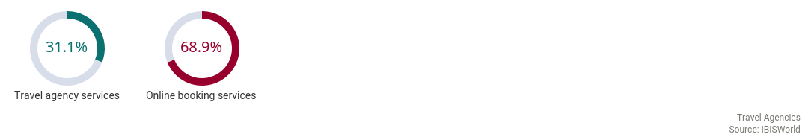

Major Players  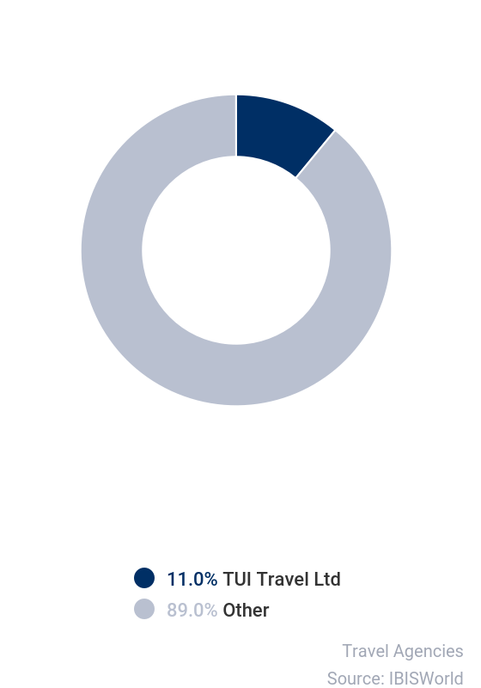 | SWOT
   | Strengths
   | Low Imports
   | High Revenue per Employee
   | Weaknesses
   | Low & Steady Barriers to Entry
   | Low & Steady Level of Assistance
   | High Competition
   | Low Profit vs. Sector Average
   | High Customer Class Concentration
   | High Product/Service Concentration
   | High Capital Requirements
   | Opportunities
   | High Revenue Growth (2021-2026)
   | Consumer confidence index
   | Threats
   | Very Low Revenue Growth (2005-2021)
   | Low Revenue Growth (2016-2021)
   | Low Performance Drivers
   | Real household disposable income

Executive Summary | The Travel Agencies industry is composed of agencies providing booking, reservation and information services to UK residents travelling domestically and internationally.  The industry performed well over the first half of the past five-year period, as people continued to prioritise holidays, despite consumer confidence dipping and the pound falling in value following the EU referendum in June 2016. However, the COVID-19 (coronavirus) outbreak and subsequent travel bans are expected to weigh on revenue over the two years through 2020-21. As a result, industry revenue is expected to fall at a compound annual rate of 2.8% over the five years through 2020-21, including revenue decline of 20.4% in the current year, to £27.5 billion.  The heatwave in the summer of 2018 proved a challenge for the industry, with revenue growth slowing to 0.1% over 2018-19, from a growth rate of 7.7% in the previous year. The weak pound contributed towards this fall in demand, although many people replaced overseas holidays with cheaper ‘staycations', which boosted domestic tourism. More consumers are choosing to make online bookings directly, bypassing high-street agencies and putting pressure on industry operators. Rising external competition over the past five-year period has constrained the industry's performance and led to the exit of more bricks-and-mortar travel agencies from the industry, and the collapse of the industry's second largest player, Thomas Cook, in September 2019. The coronavirus outbreak is expected to define the end of the period, with demand falling drastically during 2020-21.  Over the five years through 2020-21, industry revenue is expected to grow at a compound annual rate of 4.8% to reach £34.7 billion. Rising real disposable incomes are expected to result in UK tourists taking longer, more expensive and more adventurous holidays, despite the value of the pound being forecast to remain low into the medium term. In the short term, demand for cheaper package holidays due to low consumer confidence is anticipated to support the industry once travel bans have been lifted, while changes to Air Passenger Duty are likely to have a positive effect on demand for long-haul travel. Travel agencies are expected to supplement their services by fully integrating their businesses with online platforms, challenging traditional agencies to provide higher quality services.

Industry Performance
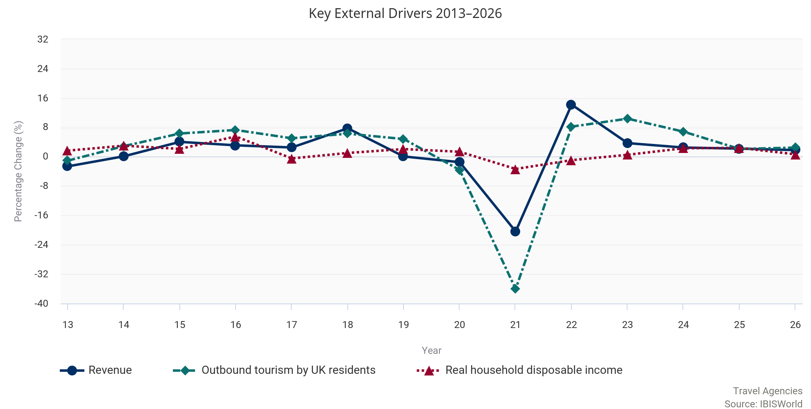

Key External  Drivers | Outbound tourism by UK residents  Changes in outbound travel by UK residents directly influence industry activity and profitability as many of these people, particularly older or first-time travellers and those travelling to new and exotic destinations, often use travel agents for all or part of their bookings. Outbound tourism is expected to decrease over 2020-21, due to travel bans following the COVID-19 (coronavirus) outbreak, posing a threat to industry operators.  Real household disposable income  The level of real household disposable income affects consumers' ability to finance travel. Higher levels of disposable income allow individuals to allocate more money to travel. Generally, this translates into more revenue for the industry. IBISWorld expects disposable incomes to fall in 2020-21, due to the economic effects of the coronavirus outbreak, though the decline is expected to be marginal, presenting a potential opportunity to the industry.  Real effective exchange rate  Changes in the strength of the pound, particularly relative to the US dollar and the euro, influence the relative cost, and therefore attractiveness, of travelling to certain destinations. A strong pound encourages Britons to travel overseas, which generates more revenue for the industry. The real effective exchange rate is expected to fall in 2020-21, discouraging UK residents from traveling abroad.  Total domestic tourism  The level of domestic travel that takes place affects industry revenue. The level of business travel is particularly important because business customers tend to use agencies to handle logistics, making travel easier and more convenient. Generally, the greater the level of domestic tourism, the more income the industry generates. In 2020-21, total domestic tourism is expected to decrease due to coronavirus-related lockdown restrictions put in place at the end of March 2020 until June 2020, which meant that UK residents were unable to travel around the country.  Consumer confidence index  Holidays are discretionary purchases, so demand for tours packaged by the industry generally rises in line with heightened financial security and consumer confidence. Average tour expenditure is also likely to be higher if consumer confidence is strong. In 2020-21, consumer confidence is forecast to fall dramatically as a result of the coronavirus outbreak, likely limiting demand.

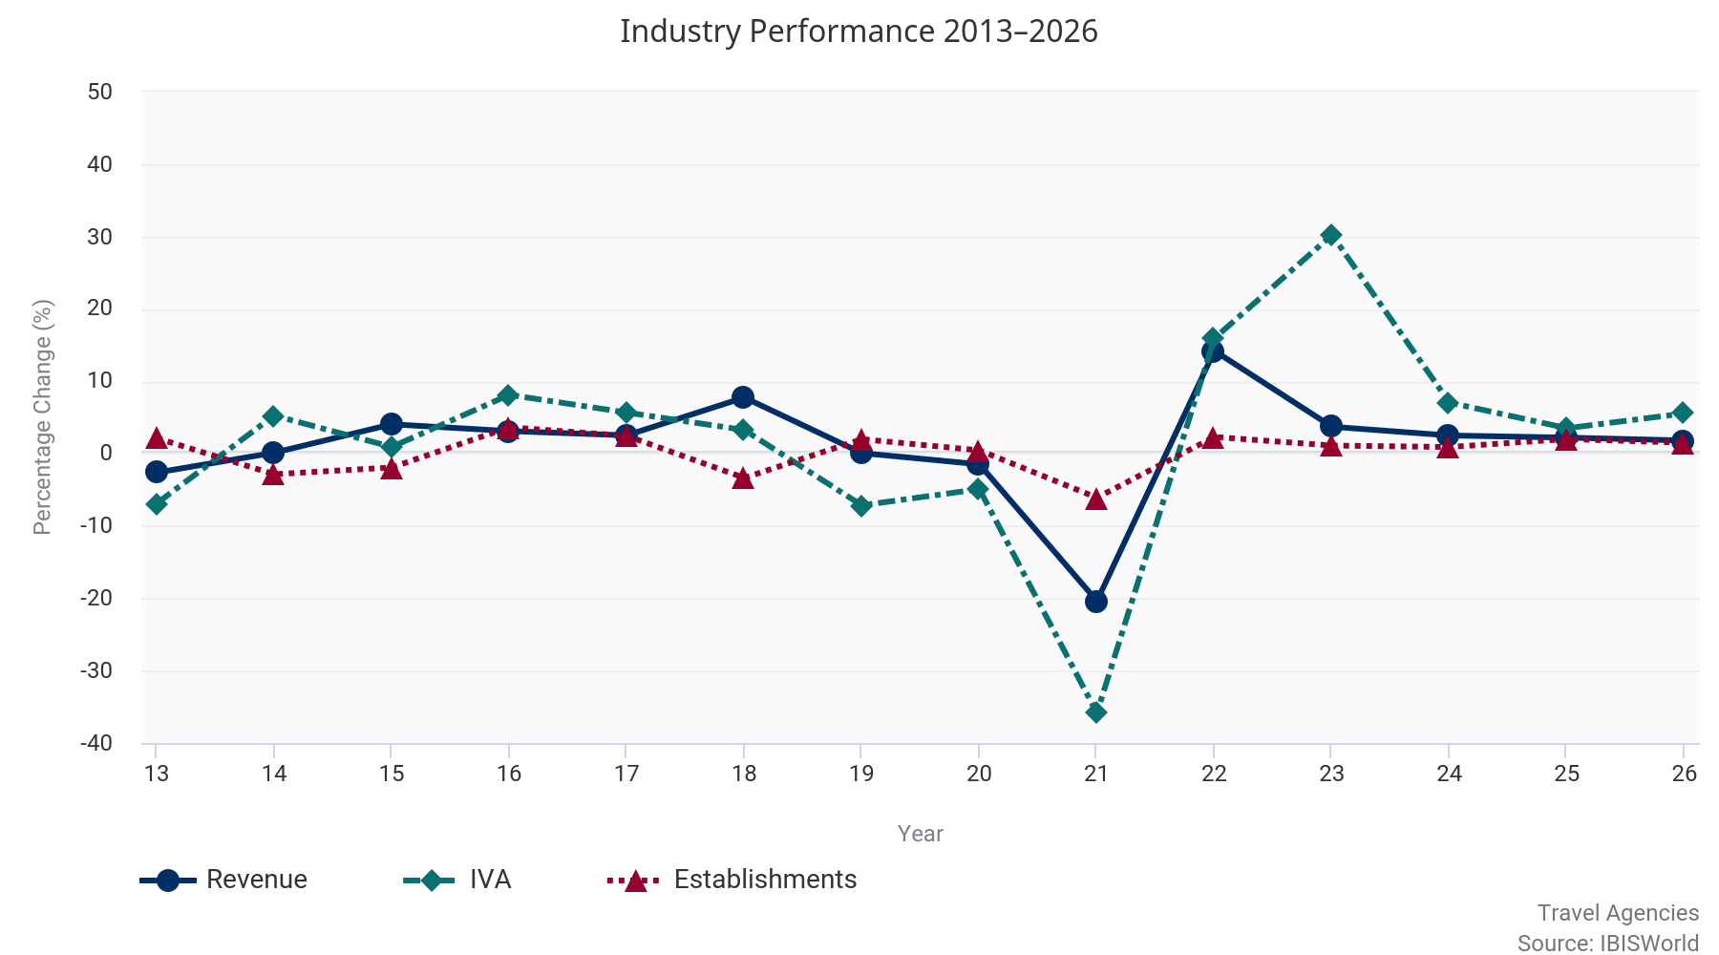

Current  Performance | The Travel Agencies industry generates revenue through commissions received, based on customers booking transport, accommodation and activities for their holiday through industry operators.  This makes revenue dependent on the number of UK residents going on holiday, and how much they are willing to spend. Economic conditions in the United Kingdom and abroad have a strong influence on these factors. Economic growth supported expansion at the beginning of the past five-year period. Despite the EU referendum subduing economic activity, the industry fared well, and revenue grew by 7.7% in 2017-18. However, growth slowed in the following year, as the weak pound, combined with the heatwave in summer 2018, reduced demand for holidays overseas. Industry revenue is expected to decline over the two years through 2020-21, as a direct result of the COVID-19 (coronavirus) pandemic, and subsequent travel restrictions put in place globally. Industry revenue is expected to fall at a compound annual rate of 2.8% over the five years through 2020-21, including a revenue fall of 20.4% in the current year, to £27.5 billion.  Current challenges  The spread of the coronavirus is expected to take its toll on industry performance in the current year.  On 29 January 2020, the Foreign, Commonwealth & Development Office (FCDO) warned against ‘all but essential travel' to China and several countries, and the United Kingdom started to take precautionary measures to limit the spread of the virus, including implementing travel bans, as well as imposing obligatory checks and quarantine measures of passengers travelling from high-risk areas such as Hong Kong and Italy. This was increased to all but essential international travel indefinitely, from 4 April 2020. The industry has already been severely affected, as airlines have restricted the number of flights on offer, and consumers have withheld from booking holidays or cancelled existing plans altogether. Since July 2020, the FCDO has changed this advice with some countries being put on a travel corridor list, meaning those coming into the United Kingdom from these destinations are exempt from a 14-day quarantine period. This has helped to support industry demand, though the re-introduction of quarantine requirements for some countries at short notice has constrained this rise in demand. Figures from the International Air Transport Association indicate that passenger demand in July 2020 continued at critically low levels of 79.8%, below July 2019 levels. This was somewhat better than the 86.6% year-on-year decline recorded in June 2020. The implementation of travel restrictions, flight cancellation and lower demand is expected to weigh on industry revenue in the current year.  Changing demand  Despite the value of the pound contracting after the EU referendum, revenue was sustained.  Nonetheless, growth slowed to 2.5% in 2016-17 from 3.1% the previous year, partially as UK residents opted for cheaper domestic holidays over international trips. According to the ABTA, the industry benefited from two strong years for domestic tourism in 2016 and 2017. Hoseasons, a travel company that offers a wide range of holidays in the United Kingdom, saw bookings for domestic trips from millennials rise by 37% during the three years through 2018. The industry also benefited from an increase in foreign tourists coming to Britain to take advantage of the low pound, with 9% more visits in December 2018 than in December 2017. However, both these trends are expected to have slowed, with the number of domestic holidays taken by UK residents falling from 2.1 to 1.8 per person over 2018, and the rise in inbound tourism slowing to 1% more visits in July 2019, compared with July 2018.  Over 2017-18, inflation outstripped wage growth, while consumer confidence continued to fall. This diminished demand for holidays, with the average number of holidays taken per person in the United Kingdom falling from 3.8 in 2017 to 3.4 in 2018, according to the ABTA. This decrease was driven by people taking fewer UK breaks and people taking fewer shorter breaks, at home and abroad. Nevertheless, both of these types of holiday have low demand for travel agents. As a result, industry revenue continued to grow over the year. In contrast, the number of longer holidays abroad increased over the three years through 2018; the percentage of people taking foreign holidays in 2018 was the highest number since 2011. Low confidence is also expected to have altered consumer behaviour in respect to their travel choices, as people have chosen to save money and spend it on one long trip rather than taking more short breaks.  Online bookings  In 2020-21, online travel agents are expected to account for 65.2% of industry revenue.  Greater internet access has led to the industry adapting technology to reach markets directly. This process, termed disintermediation, eliminates many intermediaries that would otherwise impose a cost, boosting external competition for travel agencies.  Many large travel agents, including TUI, have followed the prevailing trend and established booking websites under their own or other brands. This is expected to lead to the exit of more bricks-and-mortar travel agencies from the industry. However, high-street operators that have successfully integrated their physical presence with online operations, by allowing consumers to check itineraries and add extras to their bookings, are still able to compete effectively. The rate of closures of high-street travel agencies slowed dramatically over 2018-19, despite pressures on retailers and multiple high-profile closures of brand-name stores. The Local Data Company, a market research firm, reported that 87 agencies closed in 2018, in contrast with 2017 when 670 shut and travel agents were one of the three fastest-declining sectors. Thomas Cook closed 200 shops over the two years through 2018 before their collapse in September 2019. However, Travel Weekly has reported a spate of agency openings, with Hays Travel opening six branches from January to April 2019, as well as agreeing to buy 553 of Thomas Cook's 563 UK stores.  In the current year, many bricks-and-mortar establishments are expected to close as operators move services online in an effort to cut costs in response to falling demand. The number of enterprises is also expected to fall as smaller operators struggle to cope with the financial strain due to travel restrictions and are forced to exit the industry. Following a sharp drop in the current year, the number of establishments operating in the industry is expected to decline at a compound annual rate of 1% over the five years through 2020-21. Employment is expected to fall at a compound annual rate of 1.6% over the five years through 2020-21, due to a decline in the current year as operators are forced to let staff go amid drastically lower demand.  Industry disruption  The industry has contended with several external factors affecting consumer travel plans over the period.  These include the disturbance caused by terrorism and political unrest in Turkey, Egypt and various North African countries. The terrorist attack in Tunisia in June 2015, which disproportionately affected British tourists, led to disruption for travel companies with exposure to the country. In addition, the collapse of Monarch Airlines in October 2017 and the cancellation of 18,000 flights by Ryanair between November 2017 and March 2018, are expected to have hindered travel agencies that booked flights through these airlines. Hot weather in the summer of 2018 also led to a larger profit decline than anticipated for some operators as fewer people chose to book last-minute holidays. The industry was rocked by the collapse of the second largest operator, Thomas Cook, who had been operating since 1841. TUI has suffered from similar trends of fewer people using travel agencies. However, smaller debts have allowed the firm to continue operating, and it is expected to benefit from former Thomas Cook customers booking holidays at higher prices through their brand.

Historical Performance Data
Year | Revenue  (£m) | IVA  (£m) | Establishments  (Units) | Enterprises  (Units) | Employment  (Units) | Exports  (£m) | Imports  (£m) | Wages  (£m) | Domestic  Demand  (£m)
2011-12 | 30,314 | 4,082 | 7,271 | 3,847 | 60,947 | N/A | N/A | 2,311 | N/A
2012-13 | 29,517 | 3,800 | 7,426 | 3,794 | 58,835 | N/A | N/A | 2,168 | N/A
2013-14 | 29,551 | 4,000 | 7,214 | 3,925 | 57,991 | N/A | N/A | 2,139 | N/A
2014-15 | 30,746 | 4,037 | 7,075 | 4,070 | 55,284 | N/A | N/A | 2,070 | N/A
2015-16 | 31,701 | 4,364 | 7,332 | 4,414 | 56,801 | N/A | N/A | 2,213 | N/A
2016-17 | 32,499 | 4,612 | 7,511 | 4,690 | 57,190 | N/A | N/A | 2,272 | N/A
2017-18 | 35,015 | 4,762 | 7,258 | 4,565 | 58,449 | N/A | N/A | 2,311 | N/A
2018-19 | 35,038 | 4,421 | 7,402 | 4,619 | 60,027 | N/A | N/A | 2,319 | N/A
2019-20 | 34,518 | 4,204 | 7,435 | 4,596 | 59,367 | N/A | N/A | 2,271 | N/A
2020-21 | 27,485 | 2,697 | 6,982 | 4,407 | 52,481 | N/A | N/A | 1,872 | N/A

Industry Outlook
Outlook | Over the five years through 2025-26, IBISWorld expects industry revenue to grow at a compound annual rate of 4.8% to reach £34.7 billion.  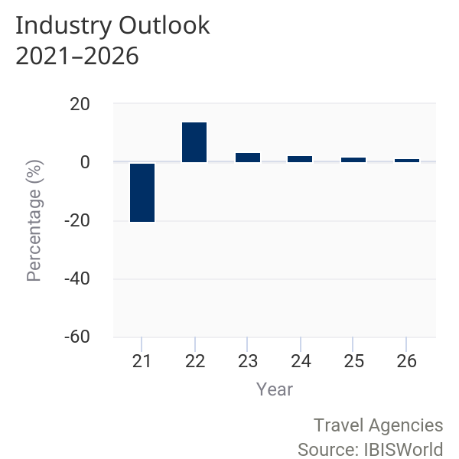  The coronavirus outbreak is expected to continue to take its toll on industry operators in the short run as travel bans remain in place for some countries. Whilst the government has lifted travel restrictions for some countries, others remain off the travel corridors list, meaning arrivals to the UK from these destinations must quarantine for a 14-day period. As a result, some consumers are continuing to postpone making travel arrangements and booking holidays while the situation remains unclear. Falling consumer confidence and a more cautious mindset of travellers following the virus outbreak is expected to lead to constrained spending on holidays in the short term, despite continued expansion over the coming period. However, the weak pound is expected to boost the number of international tourists visiting the United Kingdom over the next five years, supporting revenue growth. The industry is exposed to unpredictable political and environmental factors that could lead to slight volatility in revenue, profit or wage costs over the next five years. Online operators are anticipated to continue putting pressure on the industry and on profit margins, which are forecast to rise at a slow pace. New trends are emerging in the holiday market, including demand for personalised expert travel advice in an age of limitless choice and information online, according to ABTA. Additionally, package holidays are likely to prove a popular choice in the search for good value as low consumer confidence and the weakness of the pound persist.  Many companies are anticipated to move more operations online, leading to the exit of bricks-and-mortar travel agencies from the industry. This will likely result in larger operators continuing to record revenue growth as they are better connected and understand the needs and booking preferences of the contemporary traveller. However, consumers are less likely in the short term to purchase high-margin packages, such as extended holidays or luxury winter sun breaks, due to political and economic uncertainty resulting from the UK's exit from the European Union and the global coronavirus pandemic.  Destination online  Although the weak pound is likely to reduce buying power and lower confidence, limiting demand for industry services, this is expected to be offset by increased interest in travelling from millennials.  As the tech-savvy millennial generation spend more on holidays, incumbents must be flexible in adapting operations to meet changing consumer preferences. As a result, the number of online travel booking sites is forecast to continue growing, and travellers are expected to become increasingly confident about cutting out travel agents and booking directly from tour and travel providers. The industry is therefore likely to be characterised by rising competition over the next few years. The number of enterprises is expected to grow at a compound annual rate of 1.9% over the five years through 2025-26, while the number of establishments is expected to grow at a slower rate of 1.6%.  According to ABTA, 76% of holiday bookings were made online in 2016, increasing to 81% in 2018. The proliferation of travel apps is expected to encourage more people to use online booking as it allows them to book at times that suit them, to compare various packages and tariffs and to arrange their own itinerary. 12% of people booked their holiday on a mobile phone in 2018; however, this was down from 20% in the previous year. IBISWorld expects the industry to separate into small niche players that offer more specific products, such as religious pilgrimages, or that target certain destinations or experiences. Given their higher fixed costs and declining commission margins, traditional shop-front agencies that do not operate in a niche market are likely to come under increasing pressure to consolidate.  As the level of competition from online sources rises, high-street travel agents will need to focus more on the quality of service offered, combining depth of knowledge and new technology. There will continue to be a place for high-street travel agents able to explain complicated information that inexperienced consumers encounter on the internet. The key to meeting the challenge of travel agency websites will be switching towards dynamic, customised package holidays.  Traveller trends  Although revenue is expected to grow consistently over the five years through 2025-26, the industry is in a transitional stage and operators will continue to face fresh challenges.  The collapse of Thomas Cook in September 2019 is expected to make consumers cautious about booking holidays through a travel agent, although the largest impact from this is likely to be felt in the Tour Operators industry (N79.120 Tour Operators in the UK). The sudden outbreak of coronavirus and the help offered to stranded holidaymakers and those who had future trips booked through their travel agent may reverse this trend somewhat. In addition, the enduring desire of consumers to take regular holidays, domestically or internationally, is likely to ensure that the market for travel agents remains stable. Demand for dynamic package holidays is anticipated to support the industry's performance, as consumers are more likely to use a travel agent when booking package holidays. Other growing trends include cruise ship travel, responsible travel and solo travel, all of which are more likely to be booked through a travel agent than by the consumer. Cautious spending is expected to keep value at the forefront of consumers' minds when searching for holidays.  Flying high  Further changes to Air Passenger Duty (APD) are expected to occur over the next five years.  In April 2018, band B APD rates rose marginally, with RPI inflation reaching £78 for reduced rate travel, £156 for the standard rate and £468 for higher rate travel, while band A rates remained stable. This meant that short flights became less expensive as band A APD rates remained steady while inflation pushed up wages. However, APD charges for flights in band B remained proportional. In April 2019, band B rates rose again to £172 for the standard rate and £515 for higher rate travel.  Another concern for the industry is the potential changes to the UK's access to the EU single aviation market following the end of the transition period. Airlines in the United Kingdom are currently included in the single aviation market, which enables them to land freely in EU member states. Approximately 3,000 planes bound for overseas destinations depart from the United Kingdom every day, meaning any changes in the UK's access to the single aviation market are likely to have a notable effect on the industry.
Performance Outlook Data
Year | Revenue  (£m) | IVA  (£m) | Establishments  (Units) | Enterprises  (Units) | Employment  (Units) | Exports  (£m) | Imports  (£m) | Wages  (£m) | Domestic  Demand (£m)
2020-21 | 27,485 | 2,697 | 6,982 | 4,407 | 52,481 | N/A | N/A | 1,872 | N/A
2021-22 | 31,388 | 3,127 | 7,142 | 4,518 | 56,626 | N/A | N/A | 2,091 | N/A
2022-23 | 32,549 | 4,071 | 7,221 | 4,576 | 57,533 | N/A | N/A | 2,151 | N/A
2023-24 | 33,363 | 4,358 | 7,286 | 4,686 | 57,935 | N/A | N/A | 2,189 | N/A
2024-25 | 34,097 | 4,510 | 7,432 | 4,789 | 58,457 | N/A | N/A | 2,226 | N/A
2025-26 | 34,711 | 4,761 | 7,543 | 4,832 | 59,217 | N/A | N/A | 2,262 | N/A
2026-27 | 35,995 | 4,988 | 7,619 | 4,881 | 60,046 | N/A | N/A | 2,324 | N/A

Industry Life Cycle | The life cycle stage of this industry is Mature  LIFE CYCLE REASONS  Product lines are well defined  Internal competition in the industry is increasing  Competition is based on price  IVA growth is expected to grow at a similar pace to GDP growth over the decade through 2025-26

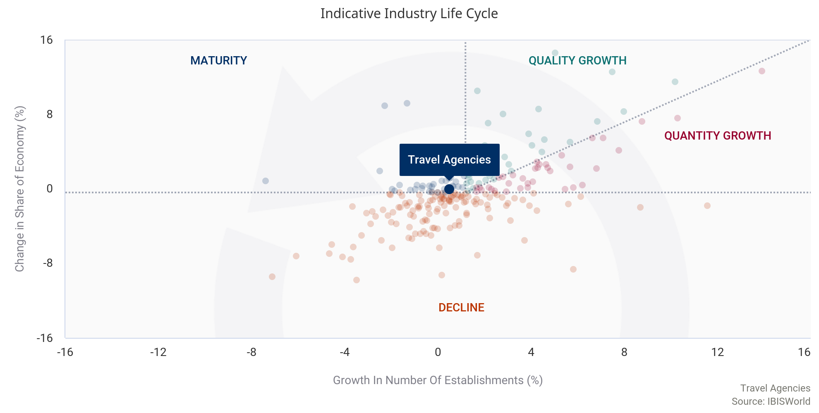

The industry is currently developing at two different speeds. Most high-street operators are in decline, but online platforms are growing, and the industry is considered to be mature overall. Traditional bricks-and-mortar establishments are continuing to battle for their share of consumer spending against the increasingly popular travel booking websites. Over the five years through 2025-26, business and consumer bookings made online are expected to rise from about 50% to approximately 70% of total travel bookings. Major players have increased the amount of content and services available online to boost revenue.
The industry has been negatively affected by disintermediation. Travel product suppliers are getting closer to customers and selling directly to them. This process eliminates many intermediaries that impose additional costs, such as commissions. The industry is also segmenting into large international operators and small niche agencies. While travel agency websites are showing some growth, they are also competing against sites owned by travel operators. Travel operators' websites encourage their customers to book directly with them, offering competitive prices, customer loyalty schemes and bonuses.
Overall, the industry is expected to record moderate growth in revenue, mostly achieved by travel agency websites. Over the 10 years through 2025-26, industry value added, a measure of the industry's contribution to the overall economy, is expected to grow at a compound annual rate of 0.9%. The UK economy is expected to grow at a similar compound annual rate of 1.3% over the same period, which is a defining characteristic of a mature industry.

Products & Markets
Supply Chain
  Key Buying Industries
  1st Tier
  Research on Natural Sciences & Engineering in the UK
  Consumers in the UK
  Photographic Activities in the UK
  Management Consultants in the UK
  Activities of Head Offices in the UK
  2nd Tier
  Crude Petroleum & Natural Gas Extraction in the UK
  Key Selling Industries
  1st Tier
  Intercity Passenger Rail Transport in the UK
  Urban Passenger Rail Operations in the UK
  Bus & Tramway Operations in the UK
  Sea & Coastal Passenger Water Transport in the UK
  Inland Passenger Water Transport in the UK
  2nd Tier
  Scheduled Passenger Air Transport in the UK

Products & Services | 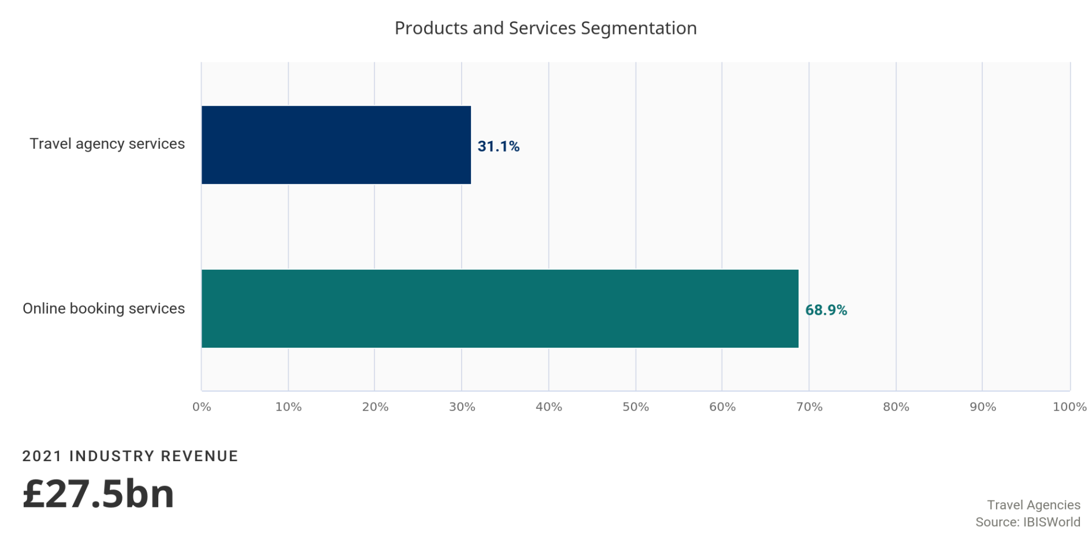
Online booking services
The UK online travel agency market is one of the largest in Europe and ahead of Germany and France.

Over the past decade, the online market has grown from slightly more than 10% of industry revenue to an expected 68.9% in 2020-21. The online travel segment relates only to travel websites that offer flights with a range of airlines, accommodation and other products, such as Expedia. It excludes the websites operated by major airlines and accommodation chains since these are included in other industries.
Websites have the advantage of being accessible 24 hours a day, so they trade on convenience. Many online operators can also offer more attractive prices than their competitors because they have far lower operating and overhead costs than shop-front operators. Many currently charge no booking fees. One of the advantages associated with these websites from the tourism operators' perspective is that the prices offered online can be adjusted rapidly to match demand and vacancies, including for last-minute bookings.
The online travel segment is continuing to expand rapidly, leading to fragmentation and the existence of many niche operators. These operators tend to be more capital than labour intensive, although many websites are linked to call centres that provide customer support services. The growth of the online segment has been backed by developments in the way people can book. A 2013 survey by the Association of British Travel Agents found that approximately 20% of online bookings were made using a mobile phone or tablet device. This figure grew to just under 40% in January 2018, and is expected to have risen further since. Even bookings that are not made online have often been digitally influenced and a growing proportion of research is done via mobile sites or apps. Younger and more tech-savvy consumers are more likely to book trips through online travel agents.
Travel agency services
The traditional travel agency is a retail business that sells travel-related products on commission.

These products include domestic and international travel by plane, cruise ship, train, bus or hire car, as well as accommodation, tours and attractions. They also offer high-margin products, such as travel insurance, and many sell luggage allowances and travel accessories. Travel agencies can be independent, chain or franchised operators, and most are linked through a global distribution system to the products on offer. Global distribution systems allow information to be shared, bookings confirmed and reservations made and provided instantly to customers. The major global distribution system in operation in the United Kingdom is Amadeus, which is one of the systems that Expedia uses to support its online system.
Bricks-and-mortar travel agencies seek to compete with their online competitors by emphasising the ease of mind and professionalism they can provide by dealing with customers face-to-face. All UK travel shops that provide air transport must be registered with the Civil Aviation Authority through Air Travel Organisers' Licensing. This provides people booking their trips with a high degree of security.
Firms in this segment typically have a labour-intensive structure and have to deal with the significant costs associated with office leasing and overheads. The average commission on sales is 10%, but it may be lower for airlines. Some low-cost flyers offer zero commission to encourage their customers to book directly through their websites. This segment of the industry is under increasing consolidation pressure due to demographic, customer and technological changes, and particularly from competing travel websites. Travel agency services are expected to account for 31.1% of industry revenue in 2020-21. In the United Kingdom, the major bricks-and-mortar travel agent operator is TUI, following the collapse of Thomas Cook in September 2019, although TUI has made a concerted effort in recent years to increase sales through internet-enabled devices with investment in digital platforms a key strategic decision. Due to the outbreak of COVID-19, some travel agents have been forced to close their bricks-and-mortar stores due to social distancing measures. If agents have been unable to reopen their stores, the share of revenue attributed to this segment is likely to continue to decline over the next five-year period.
Major Markets | 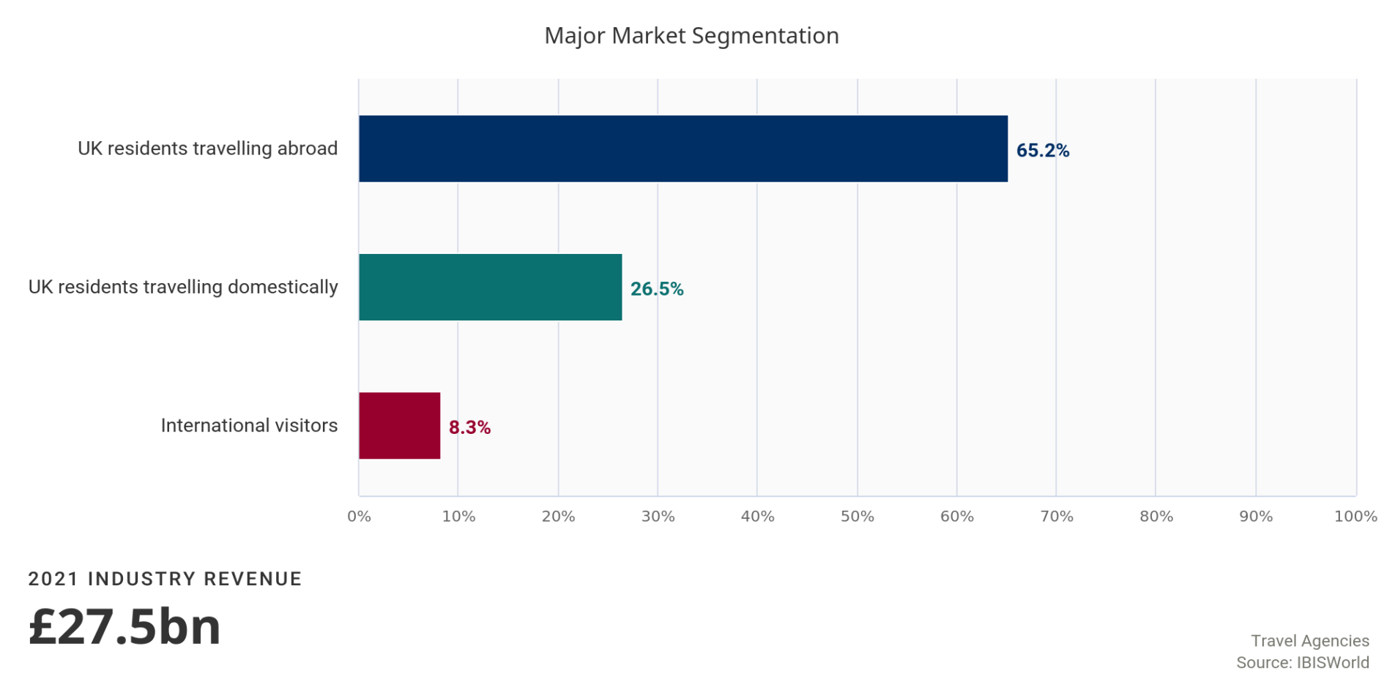
UK residents travelling abroad
UK residents travelling abroad are expected to account for 65.2% of revenue in 2020-21.

Following the continuation of international travel restrictions in the current year, in the form of a travel corridors list, domestic travel may attract demand from this segment as people choose to holiday at home since COVID-19 (coronavirus)-related lockdown measures have been lifted in order to avoid a 14-day quarantine period on their arrival back in the United Kingdom. However, this segment's share of revenue will likely recover and grow further once restrictions on international travel are lifted and more countries are placed on the travel corridors list. This segment's share of revenue is expected to fall marginally during the current year, mainly owing to the fall in the value of the pound.
Prior to the coronavirus outbreak, the most favoured destinations included Spain, France, the United States, Ireland, Italy, Greece, Germany and Portugal, according to the International Passenger Survey. Destinations that have been affected by terrorist activity over recent years have waned in popularity. Consumers have opted for more established holiday destinations as a result.
Many inexperienced travellers still seek the certainty, experience and professional advice provided by travel agents. Recognising the value and peace of mind that booking with a tour operator offers in uncertain times, holidaymakers who would not have previously considered booking a package holiday are now also taking a second look. According to Mintel, the volume of the package holiday market is expected to grow by 7.5% from 2017 to 2022. However, an increasing number of people are booking online, using word-of-mouth recommendations from friends and relatives who may have already travelled to these destinations. Older consumers are more accustomed to using travel agents therefore demand for industry services are higher amongst this demographic group. The average number of holidays taken per person in the United Kingdom fell from 3.8 in 2017 to 3.4 in 2018, and they are spending less due to subdued economic conditions, according to the Association of British Travel Agents (ABTA).
UK residents travelling domestically
Despite the high proportion of spending, the domestic market is not a prime source of business to the industry given the relative confidence and experience of Britons travelling within their own country.

The two predominant domestic segments are business travellers and tourists looking for package holidays. Business travellers tend to require the services of travel agents due to time constraints, while those booking package tours often require assistance from travel agents, particularly when seeking advice regarding special deals.
UK residents travelling domestically are expected to account for 26.5% of industry revenue in 2020-21, a slightly smaller share than five years ago, due to more people spending on holidays abroad as real household disposable incomes have risen slightly. Following two strong years of growth over 2016 and 2017 as the fall in the value of the pound has caused some travellers to seek the cheaper option of domestic tourism, the number of domestic holidays fell from 2.1 to 1.8 per person over 2018, according to the ABTA. More millennials are choosing to travel domestically rather than internationally, in order to explore what the United Kingdom has to offer, as they went on overseas rather than domestic holidays as children following the growth of low-cost airlines in the 1990s. This segment's share of revenue is expected to increase in the current year as international travel restrictions remain in place, with local restrictions having been lifted prior to international ones.
International visitors
International visitors are expected to account for 8.3% of industry revenue in the current year.

International tourists use travel agents to plan trips within the United Kingdom, including booking accommodation, booking visits to tourist attractions and hiring vehicles. Revenue generated from this segment is expected to have increased over the period, as the depreciation of the pound following the EU referendum has made holidays in the UK less expensive to those from overseas. Furthermore, the falling pound has boosted an influx of shoppers from overseas. For example, overseas tourists' expenditure was £22.5 billion in 2016, an increase of 2% compared with 2015, according to the Office for National Statistics. However, the industry is expected to see a slight dip in international visitors in the current year following the outbreak of the coronavirus as consumers postpone or cancel holidays, and airlines impose travel restrictions from those abroad.
Exports in this industry are Low and Steady
Imports in this industry are Low and Steady
Imports and exports are not included in the Travel Agencies industry. However, the industry is highly globalised, due to the nature of its dealings with international transport and tourism services.

Business Locations | 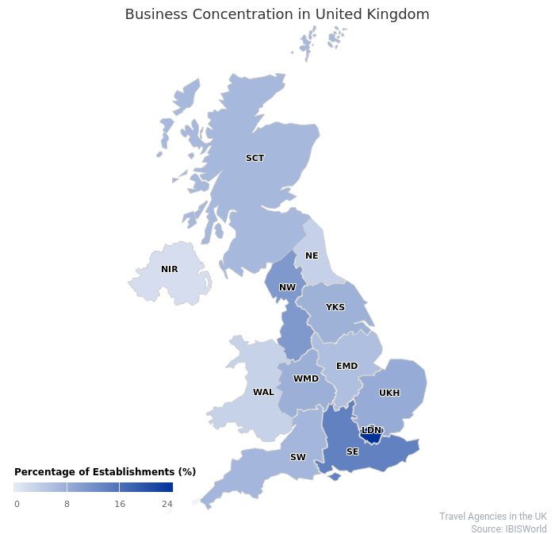
The spread of the industry follows the distribution of the population, since it serves a wide range of people. The regions where the industry is most concentrated are London, the South East and the North West, which are the most densely populated.
London
London is home to 24.1% of industry establishments. This region has about 8.9 million residents and has the highest gross disposable income per capita. It is a globally recognised tourist destination and one of the most influential financial and business centres. Furthermore, more than half of inbound tourist spending is spent in London. London, given its share of higher income households, also dominates in terms of average expenditure on travel.
The South East
The South East, which has the advantage of being close to London, has a population share of 13.8% and accounts for the same share of industry locations. It has the UK's second highest share of gross disposable income, a good determinant of industry demand, particularly for travelling abroad.
The North West
The North West accounts for an expected 10.7% of industry establishments, which is similar to its 11% share of the population. While it has lower average gross disposable incomes than London and the South East, it is still the region with the third highest level of gross value added.
Other
The other regions of the United Kingdom are not considered significant financial and business centres, as they have smaller population shares and lower average disposable incomes. These regions tend to have a larger share of small or independent travel agents.
 | 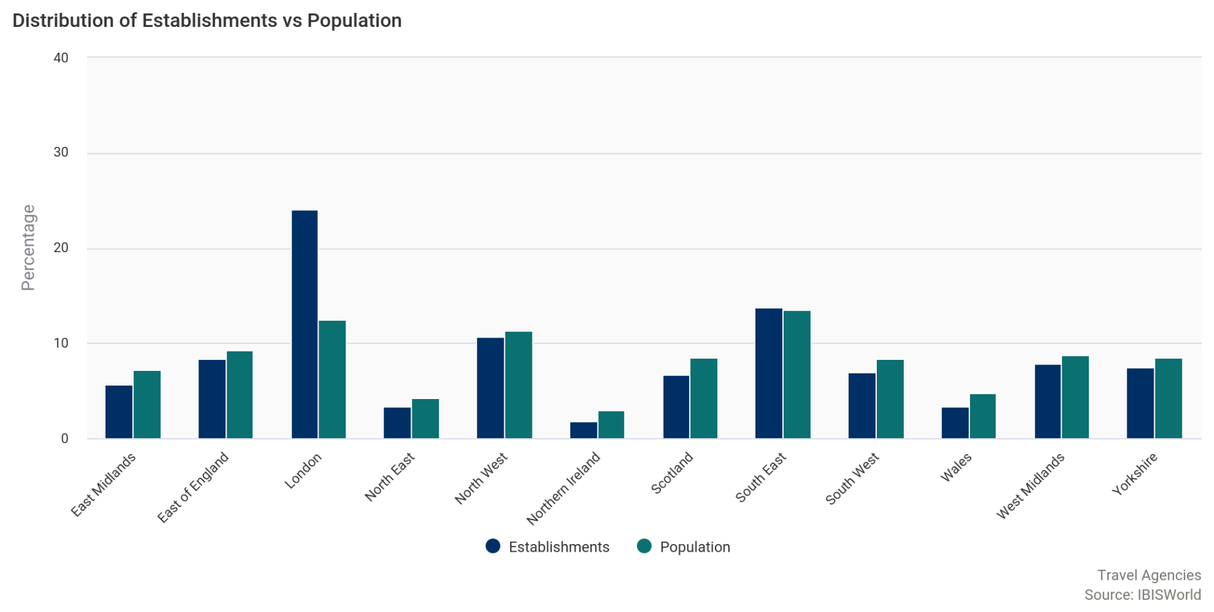

Competitive Landscape
Market Share Concentration | Concentration in this industry is Low  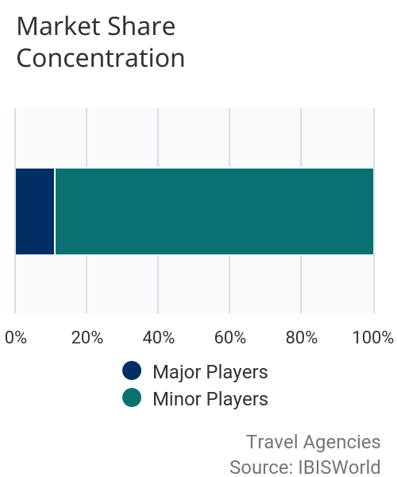  The Travel Agencies industry is highly fragmented. The vast majority of establishments have few employees, with an expected 95.1% of establishments employing fewer than 20 people. This highlights the large number of independent and owner-operated agencies in the industry. Despite this, there are a number of large international operators, including TUI, that operate bricks-and-mortar outlets, although this is less prevalent following the collapse of Thomas Cook in September 2019. Following the collapse, Hays has agreed to buy 553 of Thomas Cook's 563 UK stores. These operators are improving their position in the industry through acquisitions, and by tapping into the growing online travel bookings segment. In 2020-21, the industry's level of market share concentration is projected to remain low, with the top four companies accounting for an estimated 13.3% of industry revenue. A few large travel booking websites operate under a variety of brands to gain access to various market segments and types of bookings, such as airline tickets, accommodation or adventure and student travel. Larger operators mainly run under a niche; for example, TUI offers a large variety of family friendly package holidays, whereas Trailfinders focuses on tailor-made itineraries. There are many independently operated websites due to low barriers to entry for online operators, which means the online segment of the industry is fragmented. However, acquisitions by major players mean that they are increasing their dominance. Such firms use extensive marketing to increase consumers' brand awareness and encourage brand loyalty. Larger online operators also provide 24-hour customer support by email or through call centres. The level of market share concentration in the industry is expected to rise to some extent over the five years through 2025-26 as major operators extend their reach, mostly through acquisition activity. Consolidation of the independent and small chains and franchised shops is likely to occur as travellers continue to use online services. This environment will require operators to focus more on meeting changing consumer needs and catering to their preference for booking travel online.
Key Success  Factors | IBISWorld identifies 250 Key Success Factors for a business. The most important for this industry are:  Ability to quickly adopt new technology:  Travel agents must adapt to emerging technology quickly. The move to providing services online is a major change that enterprises are likely to implement.  Use of high volume/low margin strategy:  Due to significant competitive pressure from corporate booking websites, the industry is rapidly becoming a high-volume, low-margin industry. Smaller operators must consider offering more expensive value-added services in niche markets.  Development of new products:  Offering products that can be adapted to meet clients' needs can give a business a competitive advantage.  Access to multiskilled and flexible workforce:  Having staff that are well trained, know their products, have travelled extensively and can provide excellent customer service is vital to retaining customers.  Business expertise of operators:  Smaller travel agents can benefit from building relationships with hotels and tourism operators abroad, which then offer good deals when selling to their customers in the United Kingdom.
Cost Structure  Benchmarks | 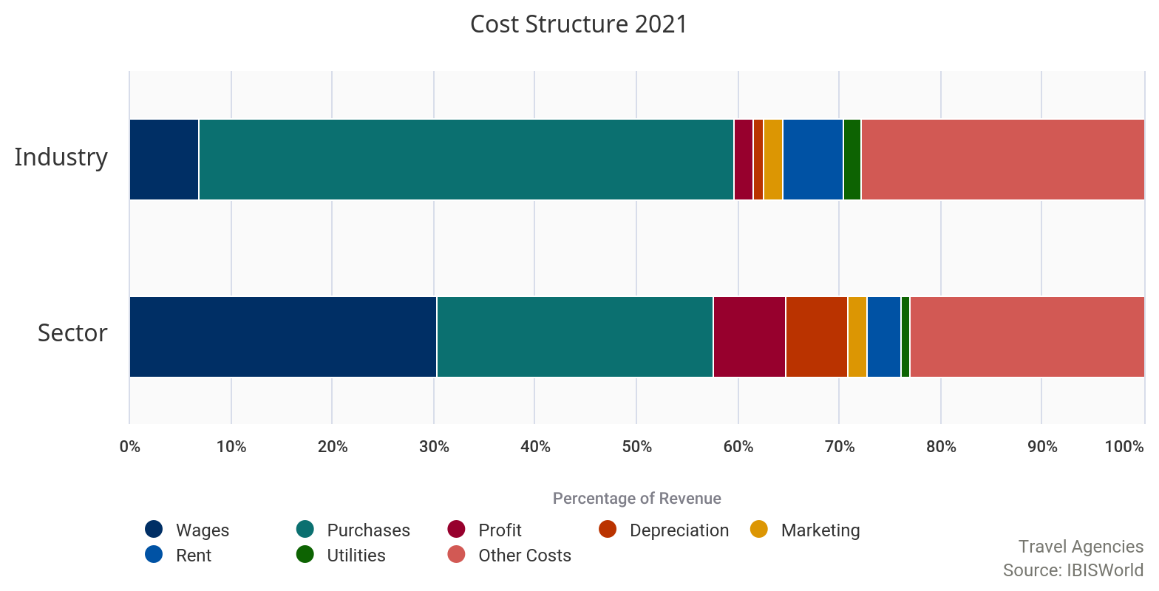
 | Profit  Profit margins for online operators tend to be higher than for their physical counterparts due to lower labour and overhead costs. The increasing importance of the internet has created an opportunity for operators to lower costs by moving operations online; firms that have taken advantage of this are expected to have higher profit margins.  The average industry profit margin is expected to fall to 1.9% in 2020-21, from 5.9% in 2015-16. This can be largely attributed to falling sales towards the end of the period, following hotter than expected summers in these years. Moreover, since the outbreak of COVID-19 (coronavirus), numerous consumers have cancelled or postponed booking holidays. Lower demand and cancelled itineraries are likely to weigh on profit as firms attempt to sell tickets at discounted prices, putting downward pressure on margins. Industry operators have also been forced to offer refunds to consumers who had holidays cancelled during the lockdown period, weighing heavily on margins in the current year. The EU referendum result and subsequent fall in the value of the pound and declining consumer confidence have not significantly affected profitability over the past five-year period. | 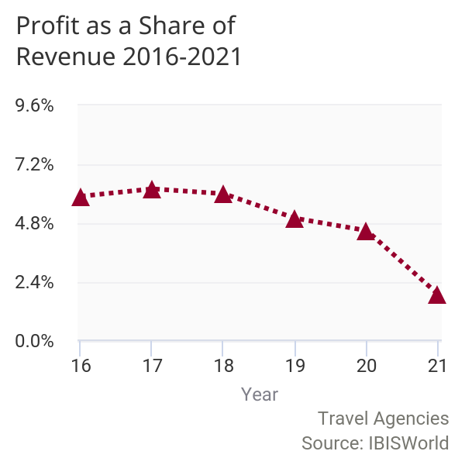

 | Wages  Travel agents concentrate on providing their customers with a high-quality service. In many areas, this still involves a large component of personal service and advice, including making recommendations; issuing e-tickets; comparing airlines' prices, travel schedules and routes; providing travel schedules; and making and confirming reservations, even though much of this activity is computerised and involves using an online global distribution system. Experienced consultants can provide an extra level of expertise and planning, as well as speed in booking.  Wage costs have fallen as a percentage of industry revenue, over the past five years due to the changing staff mix in the industry; many customer-facing agents have been replaced with back office employees designed to support online businesses, while employment levels overall have only very marginally increased. Wages are expected to account for 6.8% of industry revenue in 2020-21. Nonetheless, nearly 10% of employees in the industry were affected by the introduction of the National Living Wage in 2016, according to the Office for National Statistics. If wage costs rise, more expensive physical premises are likely to come under pressure to close and online businesses will become more prolific. | 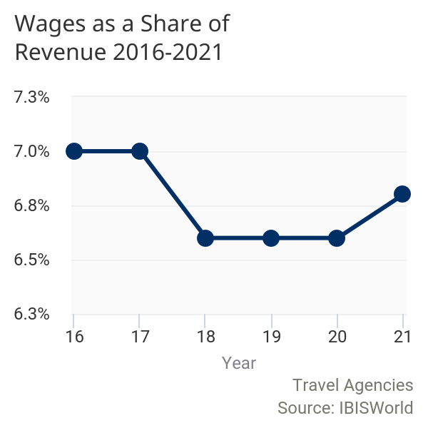

 | Purchases  The largest cost for the industry is purchases, which are expected to account for 52.8% of industry revenue in 2020-21. Travel agents require access to global distribution systems so they can provide customers with joined up services. This is a fundamental running expense for any travel agent. Since they need to have packages available to sell on to their clients, paying suppliers for tour packages absorbs the bulk of industry operators' spending. Flights bought in bulk from airlines, to be able to be sold on to customers at a slightly discounted price, also absorb a large proportion of operators' purchases. Other purchases include items such as brochures that aim to persuade customers to buy from travel agents. | 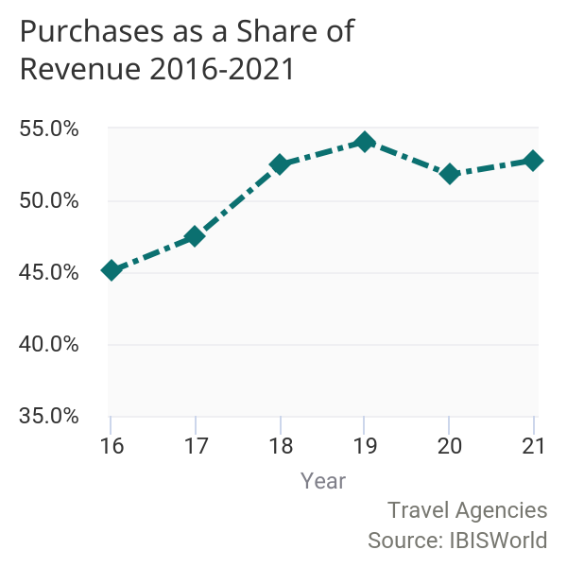

 | Marketing  Operators also bear the cost of marketing, expected to account for 1.9% of revenue in 2020-21. This is higher than the sector average, as marketing is important for operators to gain reputation and a loyal customer base in this highly competitive industry. The nature of the industry means customers often shop around for the best deal. This subsequently means operators dedicate a large amount of revenue to ensuring consumers are aware of their brand and any deals that they may be offering. They also heavily advertise up and coming and on trend travel destinations and experiences, in order to appeal to the large share of the market that value this characteristic of a holiday. | 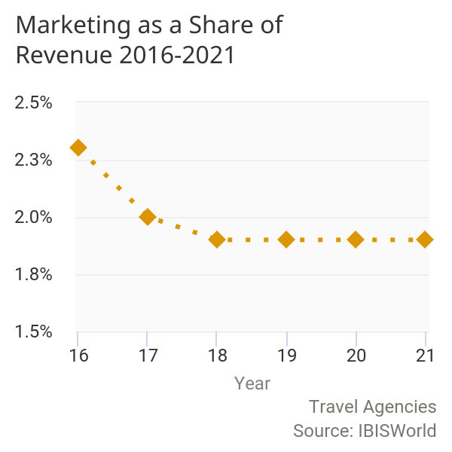

 | Depreciation  Depreciation is low in the industry but has increased due to technological change and is expected to account for 1.1% of industry revenue in 2020-21. The use of computer- and internet-based infrastructure has increased in recent years, leading to higher depreciation costs. Web hosting costs and costs associated with maintaining this equipment have also increased. | 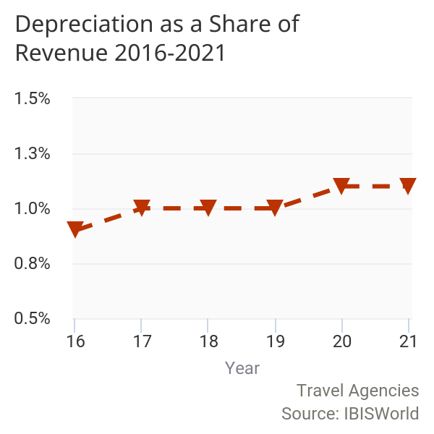

 | Rent  Rent accounts for an expected 5.9% of industry revenue in 2020-21. Stores need to be in a prominent location with high footfall to attract passing trade. A central location commands a hefty price however. London is home to the largest percentage of industry establishments due to high footfall, however rent is much higher in London than other areas of the country. In general, rent and the utilities required to operate a store are fixed costs. The increase in online activity is expected to have lowered average rent costs, though the number of establishments is still expected to increase over the five years through 2020-21. Rent costs are expected to rise as a share of revenue in the current year, as they have remained stable while revenue has fallen. | 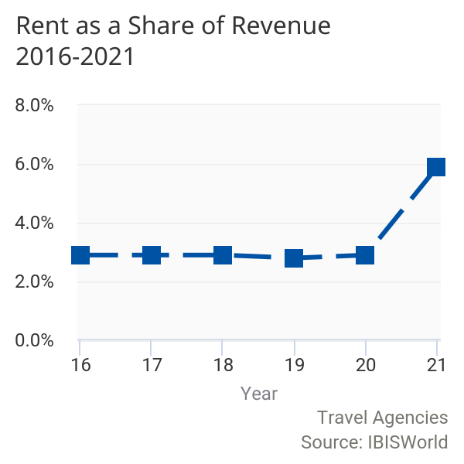

 | Utilities  Utilities are expected to absorb a further 1.7% of revenue in 2020-21. | 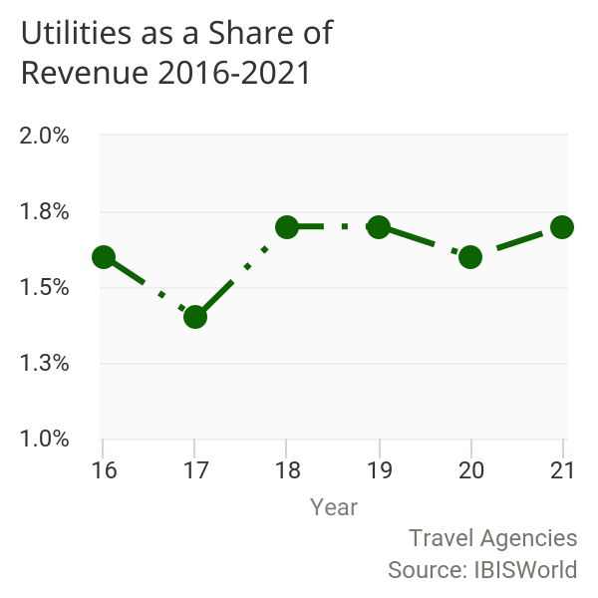

 | Other Costs  Other costs incurred relate to finance, insurance, taxes and administration. Many small agencies are affiliated to a host agency that provides training and assistance for a percentage of revenue and usually a one-off joining fee. This accounts for a substantial proportion of revenue for small agencies. Other running costs include subscriptions to industry associations such as the Association of British Travel Agents. Compliance costs are also notable, given that consumer rights and protection issues have received greater focus over the years. | 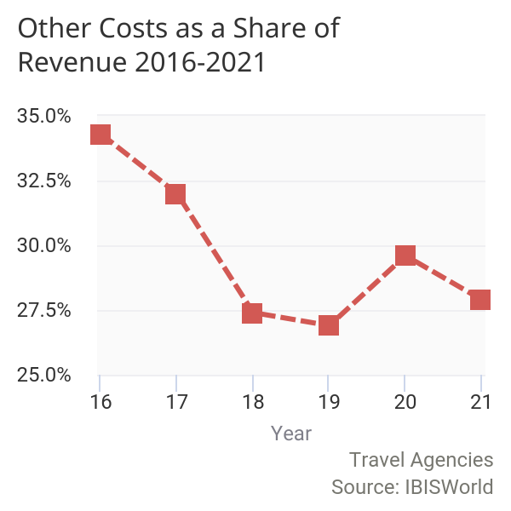

 | 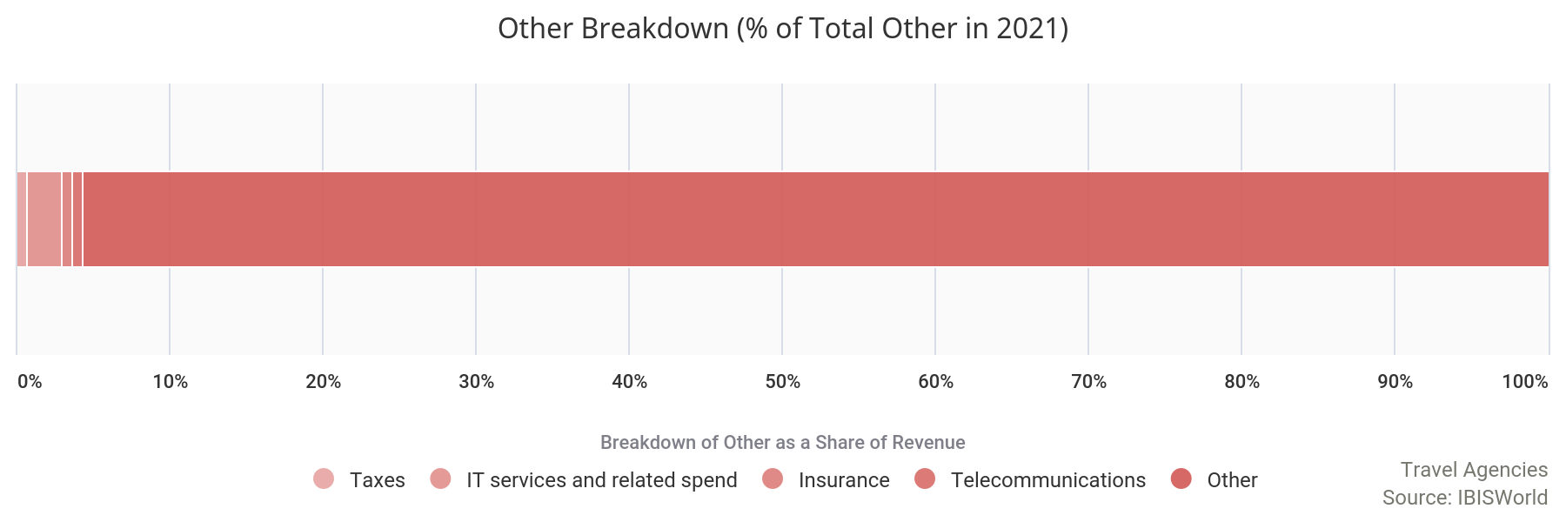
Basis of  Competition | Competition in this industry is High and the trend is Increasing
Internal competition
Internal competition focuses on price, quality and type of services and advertisement.

The emergence of travel websites has allowed consumers to compare prices across many different travel agencies in the United Kingdom in order to find the best value for money, intensifying price competition. Firms offering products and services at cheaper prices are likely to be more competitive and receive increased demand as a result.
Less experienced travellers are likely to opt for holiday packages with more services provided, for example all-inclusive stays at hotels and tours organised through travel agents. In addition, these types of travellers are likely to expect detailed knowledge of destinations and products from industry operators. Therefore, operators providing more extensive and higher quality services are likely to receive greater demand from this market. However, the wealth of information available on the internet has led to an increase in informed travellers that conduct independent research on where they would like to visit and what is available to them. This is expected to have contributed to an increase in demand for trips to more remote places, which were not traditionally thought of as common holiday destinations. Therefore, operators offering a range of services and areas are likely to be more competitive.
Firms that invest heavily in marketing are likely to reach a wider consumer base and as a result be more competitive against other industry operators. Social media has become an important tool in marketing and communications in the industry, as businesses are able to build brand awareness and customer relationships through this platform. According to a recent survey conducted by Schofields, a UK-based holiday rental home insurance provider, more than 40% of those under 33 prioritise 'Instagrammability' when choosing their next holiday spot. The picture-worthiness of a particular place beats other factors such as cost, local cuisine, and whether or not alcohol is freely available at a low cost. As a result, travel agencies that stay on top of travel trends and which destinations are being chosen by social media influencers can become more competitive within the millennial generation market.
External competition
Information on potential destinations is widely available online, and travel advice and review websites such as TripAdvisor are a source of external competition for operators, which had previously been the main source of travel information for consumers.

As a result of the availability of information on the internet, many consumers now make travel arrangements independently of travel agents. Traditional travel agents have been forced to combat online booking engines by increasing their level of service, finding a niche market and offering other add-ons such as smartphone apps. Additionally, airline and hotel websites provide a form of external competition as customers can bypass the industry by booking directly via these.

Barriers to  Entry | Barriers to Entry in this industry are Low and the trend is Steady
 | Barriers to entry into the industry are expected to be low, however barriers to achieving a large market share are high. Start-up costs are diminishing due to decreasing high street presence within the industry, although larger and established firms still benefit from economies of scale and brand recognition. Common costs involved in entering the industry include office equipment, website construction, employees' salaries, office lease deposit, trade association membership, and industry specific software, such as booking systems. However, the increasing use of the internet which has led to the transferral of the industry's operations from high street shops to online services has lowered barriers to entry by reducing start-up costs and general operating costs. New firms that focus more on online operation are less likely to be required to pay deposits and rent on shops and employ fewer customer service staff.  Regulatory costs also present a barrier to entering the industry, although since regulation is moderate, such costs are not huge. Operators must comply with the Civil Aviation Authorities' Air Traffic Organisers License regulations, which protects consumers from being stranded abroad. Operators providing food must also comply with stipulations of the Food Standards Agency while those selling package holidays must provide financial guarantees to consumers as set out in the 1992 Package Travel Regulations.  There is a certain degree of risk involved in booking a holiday; consumers' concerns about safety may lead them to favour travel agencies whose brand they trust. Building a strong brand identity and trustworthy reputation is likely to take time, and therefore acts as a barrier to entry for new firms. However, some legislation, such as ATOL, can increase consumers' willingness to book tours with an operator, making them beneficial despite increased compliance costs.  Consumers associate a considerable degree of risk with flying and are often willing to pay a premium to fly with airlines they perceive to be safer and more comfortable. Therefore, for operators who offer overseas travel services, securing contracts with established and reputable airlines will be favourable. Firms entering the industry may find it difficult to compete with bigger and more established firms for such contracts, presenting a barrier to more widespread success.  Larger firms benefit from economies of scale and therefore have more resources to spend on advertising and marketing. As a result, their services can be seen by a wider audience than new entrants, making larger firms more competitive in comparison and creating a barrier to entry.
  Barriers to Entry Checklist
  Competition | High
  Concentration | Low
  Life Cycle Stage | Mature
  Technology Change | Medium
  Regulation & Policy | Medium
  Industry Assistance | Low

Industry Globalization | Globalization in this industry is High and the trend is Steady
The industry is characterised by a high level of globalisation due to the nature of its dealings with international travel and transport. Global distribution systems link vendors and booking agents to ensure travel related services are reliably provided to consumers. The significance of online travel agents in the industry, which are more easily accessible to potential international visitors, also increases the global nature of the UK industry's services.
Following the UK's decision to leave the European Union, the value of the pound fell to historically low levels. This is expected to have led to an increase in inbound tourism as those from overseas are incentivised to take advantage of the exchange rate. ONS data indicates that in April 2017 inbound tourism was 19% higher than the same month a year earlier, before the EU referendum. In addition, spending by foreign tourists in the UK also increased as those from overseas have been incentivised to take advantage of the exchange rate. Conversely, the number of overseas visits by UK residents rose by only 2%, but their spending fell by 1% to £3.5 billion, as the low value of the pound has increased overseas expenses for British tourists. The continued low value of the pound has meant inbound tourism is still rising, with 9% more visits in December 2018 than in December 2017. This rose to 1% more in July 2019 compared to July 2018. The number of visits overseas by UK residents was 2% less in July 2019 than in the previous year.
The industry is expected to see a decline in international visitors in the current year following the outbreak of the coronavirus as consumers postpone or cancel holidays, and airlines impose travel restrictions from those abroad.

Major Companies
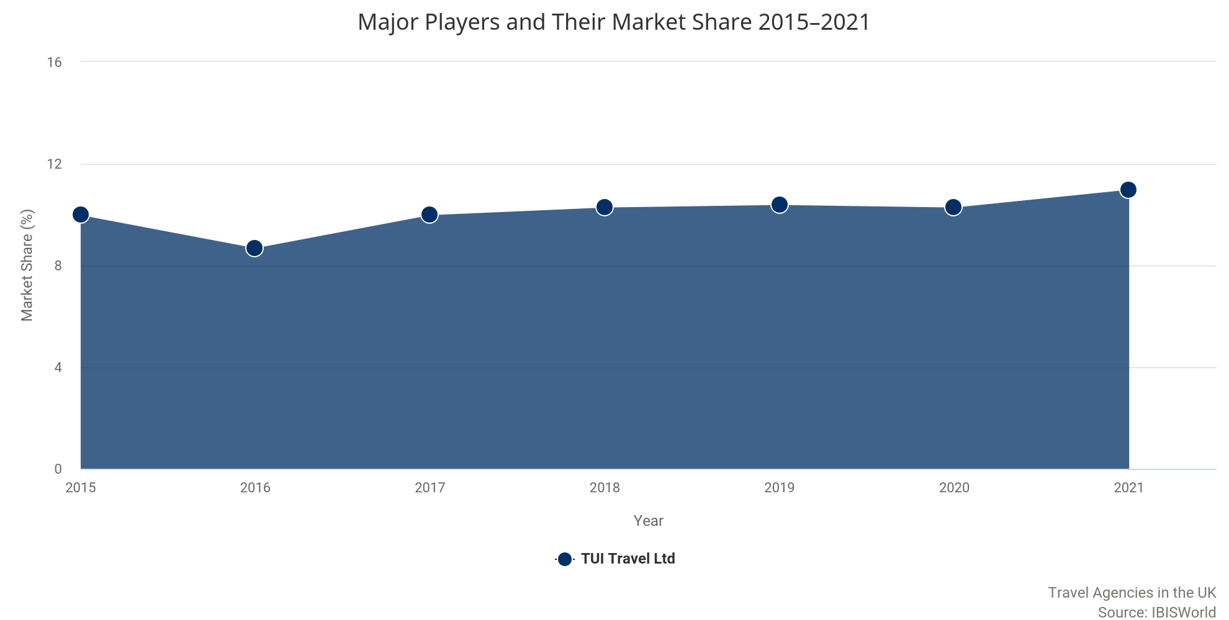

Major Players | 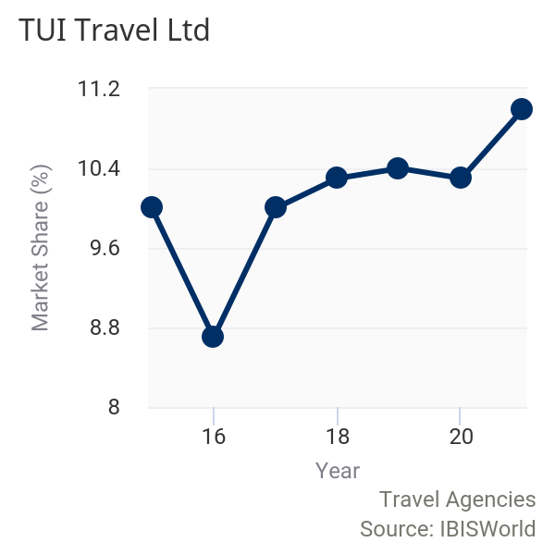  TUI Travel Ltd  Market Share: 11.0%  TUI Travel Ltd was formed in September 2007 by the merger of First Choice Holidays and TUI AG. The company was 55% owned by TUI AG until December 2014, when the merger of TUI Travel plc and TUI AG was completed to form TUI Group. As a result of the merger, TUI Travel plc changed its name to TUI Travel Ltd. The merged company is likely to benefit from significant cost savings brought about by the streamlining of its administration. TUI AG has its roots in German industry and was founded as a mining company in 1923, entering the travel market in 1997 with the acquisition of Thomson Travel. Two years later, the company fully acquired Hapag-Lloyd, which owned the subsidiary Hapag-Lloyd Cruises.  TUI Group currently operates in 180 regions and operates an expected 1,600 travel agencies, 150 aeroplanes, 17 cruise liners, and more than 380 hotels. The company claims to serve 27 million customers. TUI is headquartered in Germany and has approximately 70,000 employees. In May 2015, it was announced that UK travel agency brands Thomson and First Choice would be merged under a single brand. This was expected to take three years to complete. However, the company has instead rebranded Thompson to TUI, with First Choice remaining unaffected.  Financial performance  Over the five years through 2020-21, IBISWorld expects TUI Travel Ltd's industry-related revenue to rise at a compound annual rate of 4.1% to reach £3 billion. Before the merger, the company reported financials in pounds sterling; in the years since, it has begun to report in euros, leading to expected revenue figures for the whole period. The merger in 2014-15, prior to the start of the period, resulted in the business becoming stronger and better positioned strategically, and so revenue growth was strong over the beginning of the period. The collapse of the company's biggest rival in September 2019, Thomas Cook, affected the company as TUI travel agents offer a small selection of TUI holidays featuring Thomas Cook flights, as well as selling a small number of Thomas Cook holidays through their stores. However, the subsequent effect is expected to be marginal and may drive demand for the company in the long run as competition has been reduced.  The operations of the company over the past five years have been geared towards developing and expanding its unique property types, such as First Choice Holiday Villages, Sensatori and SplashWorld, which appeal to a wide range of consumer groups. Despite the terrorist attack in Tunisia in June 2015, which TUI was highly exposed to, revenue performance has not been significantly affected due to the range of other destinations the company offers. Part of the company's growth strategy over the past five years was to broaden its range by introducing extra flexibility into packages and expanding its long-haul offerings by taking advantage of the fleet of aircraft the company operates. The company has also improved its online presence, with the share of online sales reaching 48% in 2018-19, alongside a rise in mobile sales, which are not included in this figure. Growth has been aided by the boost in traffic from mobile devices as a result of the company's mobile app launch in June 2013. Increased use of online platforms has supported improvements in operating margins, although these fluctuated overall throughout the period.  Growth slowed over 2018-19 as the heatwave in the summer of 2018 caused a decrease in sales. Combined with the fall in the value of the pound, this meant fewer people holidaying abroad. The impact of travel restrictions on the year through September 2020, spanning into 2020-21, is expected to weigh heavily on industry revenue. With large numbers of countries enforcing temporary bans on incoming foreign nationals, and the foreign and commonwealth office advising against all but essential international travel between March 2020 and July 2020, the international travel industry came to a temporary standstill until restrictions were eased. As a result, demand for travel agents has plummeted and it is currently unclear when consumers will be able to travel again with no restrictions in place, leaving TUI's current year revenue in a very uncertain position.
TUI Travel Ltd - industry-related performance*
Year** | Revenue  (£m) | Growth  (% change)
2015-16 | 2471 | N/C
2016-17 | 2955 | 19.6
2017-18 | 3152 | 6.7
2018-19 | 3258 | 3.4
2019-20 | 3008 | -7.7
2020-21 | 3020 | 0.4
Source: IBISWorld
Note: *Estimate **Year end September

TUI Travel Ltd - financial performance*
Year** | Revenue  (£m) | Growth  (% change) | Operating Profit  (£m) | Growth  (% change)
2015-16 | 12478 | N/C | 837 | N/C
2016-17 | 15388 | 23.3 | 632 | -24.5
2017-18 | 16247 | 5.6 | 716 | 13.3
2018-19 | 16709 | 2.8 | 470 | -34.4
2019-20*** | 15270 | -8.6 | 211 | -55.1
2020-21*** | 15409 | 0.9 | 234 | 10.9
Source: Annual report and IBISWorld
Note: *Converted from euros to pounds using historical exchange rates **Year end September ***Estimate

Other Companies | Expedia.com Ltd
 | Market Share: 0.8%
Launched in the United Kingdom in 1998, Expedia is one of the world's largest online travel services, operating through its branded websites that include Expedia.com, Hotels.com, Hotwire.com and more. Expedia is the largest online travel site in the United Kingdom. In March 2013, the company completed the acquisition of a majority interest in Trivago, in line with its strategic focus to increase its global online presence and sales. In September 2014, Expedia Inc partnered with Citigroup and created the Expedia+ card, members of which can earn bonus points and earn benefits and priority customer service through the website. Expedia continues to operate the successful Travel Agencies Affiliate Programme, which launched in October 2008, offering travel agents access to Expedia's deals for a commission.
The company last reported revenue of £270.4 million for the year through December 2018. IBISWorld expects the company to report revenue of £252 million in the current year, as the coronavirus pandemic has lowered demand drastically. Profit margins for the company are also expected to fall during the year as Expedia has temporarily changed their refund and cancellation policy, to allow consumers to cancel or change the dates of their trip without losing their money.
 | Trailfinders Ltd
 | Market Share: 0.8%
Trailfinders is one of the largest independent travel companies in the United Kingdom. Founded in 1970, the company has grown to operate 38 travel centres with over 1,000 staff. The company offers bespoke services from its travel consultants and specialises in tailor-made itineraries. This company's niche offerings extend to both the luxury and standard travel sectors. The company opened their 38th branch in Winchester on 9 March 2020, despite ongoing uncertainty as a result of the global pandemic.
The company last reported revenue of £762.2 million over the year through February 2020, meaning the full effect of the coronavirus pandemic on the company's revenue is expected to be seen in 2020-21. A significant proportion of the company's revenue does not derive from travel agency operations and is therefore not included in the industry. It is expected that industry-related revenue will fall to £274 million in 2020-21 due to the coronavirus pandemic's negative affect on downstream demand.
 | Flight Centre (UK) Ltd
 | Market Share: 0.7%
Flight Centre Ltd is an Australian public-listed company that provides travel agency services. The company is administrated from its head office in Brisbane and has approximately 1,300 stores throughout its operations in Australia, New Zealand, the United Kingdom, North America, Asia and South Africa. Over 80 of these are located within the United Kingdom. The United Kingdom is Flight Centre's third largest market after Australia and the United States. The company tends to market itself to long-haul leisure travellers and to people seeking integrated business travel services. Flight Centre (UK) last reported revenue of £263.7 million during the year through June 2019.
Flight Centre has made one-third of its global workforce temporarily or permanently redundant as a result of the coronavirus pandemic. The travel agent employs 20,000 people. In total 6,000 sales and support staff will be stood down.IBISWorld expects Flight Centre (UK) Ltd to generate revenue of £218 million in 2020-21.
 | Hays Travel Ltd
 | Market Share: 0.7%
Hays Travel is the UK's largest independent travel agent that is not affiliated with any tour operators. The company has approximately 650 shops and employs over 5,700 people, following the recruitment of 2,300 former Thomas Cook shop staff after taking on the leases to occupy all 553 of its shops after the company's collapse in September 2019. It also recruited 200 additional staff for its head office in Sunderland. The company has a large presence in the North East of England, with two call centres in the region in addition to the headquarters.
The company last reported revenue of £240.6 million for the year through October 2019. The coronavirus pandemic resulted in 880 Hays staff being put on zero-hour contracts, with all other employees having their hours reduced for the four weeks from 20 March 2020. In August 2020, Hays Travel revealed that it was in discussions with 878 employees who they view as 'at risk of redundancy' as a result of a fall in demand, though the company is not considering store closures at this stage. IBISWorld expects company revenue to fall to £204.8 million in 2020-21 as reduced demand due to the coronavirus outbreak affects the business.
 | Kuoni Global Travel Services (UK) Ltd
 | Market Share: 0.1%
The Kuoni Group is an international company with almost 12,000 full-time employees and business operations in 120 countries. It is headquartered in Zurich, and is the biggest travel company in Switzerland. The Kuoni UK tour operation was established in 1966, specialising in luxury and tailor-made travel for both business and consumer markets, as well as related services such as visa processing. In 2012, Kuoni formed an arrangement with luxury department store John Lewis to become its exclusive travel partner, under which new stores were opened in various branches of John Lewis across the country. The company last reported revenue of £16.1 million for 2018.
Kuoni confirmed 70 head office and retail staff redundancies on 20 March 2020 before the government's announcement of its Coronavirus Job Retention Scheme; on 1 April 2020, staff who left the business were brought back into the business and then furloughed. A core operational and support team made up of only those staff needed to maintain smooth operations, with the remaining staff was furloughed from 1 April 2020. IBISWorld expects Kuoni Global Travel Services (UK) Ltd to generate revenue of £14.6 million in 2020-21.
 | Thomas Cook Group plc
Thomas Cook Group plc was one of the world's leading leisure travel groups, recording revenue of £9.6 billion for the year through September 2018. Thomas Cook employed approximately 9,300 individuals in the United Kingdom and operated from 16 countries, serving 20 million customers. Thomas Cook originated in 1841, however the company's most recent incarnation came into being in early 2007, when Thomas Cook AG bought out the European travel services provider MyTravel Group for £3 billion. The new company was renamed Thomas Cook Group plc and was headquartered in London.
Thomas Cook operated in the industry through two main subsidiaries: Thomas Cook Tour Operations Ltd and Thomas Cook Scheduled Tour Operations Ltd. Both companies were subsidiaries of the Thomas Cook Group plc. The company's brands in the tour operator segment included Thomas Cook Signature, Cresta Holidays, Sunworld Holidays and Direct Holidays.
Starting in 2012-13, Thomas Cook underwent significant reorganisation. As a result, it disposed of its North American business in May 2013. In November 2013, the company announced that it had agreed to sell Neilson Active Holidays. The subsidiary generated £84 million of revenue in the year through September 2012 but also recorded a loss of £9.9 million. Thomas Cook also sold a 50% share in Thomas Cook Personal Finance, three London Foreign Exchange Bureaux, and its businesses in Egypt and Lebanon. In 2014, the company agreed to sell its UK corporate travel business Co-operative Travel Management for £13.5 million to the Al Tayyar Travel Group.
Following weak demand and economic uncertainty in the first half of 2019, the Chinese firm Fosun acquired at least 75% of the groups tour operations and 25% of Thomas Cook Airlines for £450 million. The total rescue deal for the company was expected to total £900 million following an additional £450 million injection from Thomas Cook's creditors. However, it was announced that talks to produce a funding lifeline for the company had failed and, as a result, Thomas Cook ceased trading in September 2019.

Operating Conditions
 | 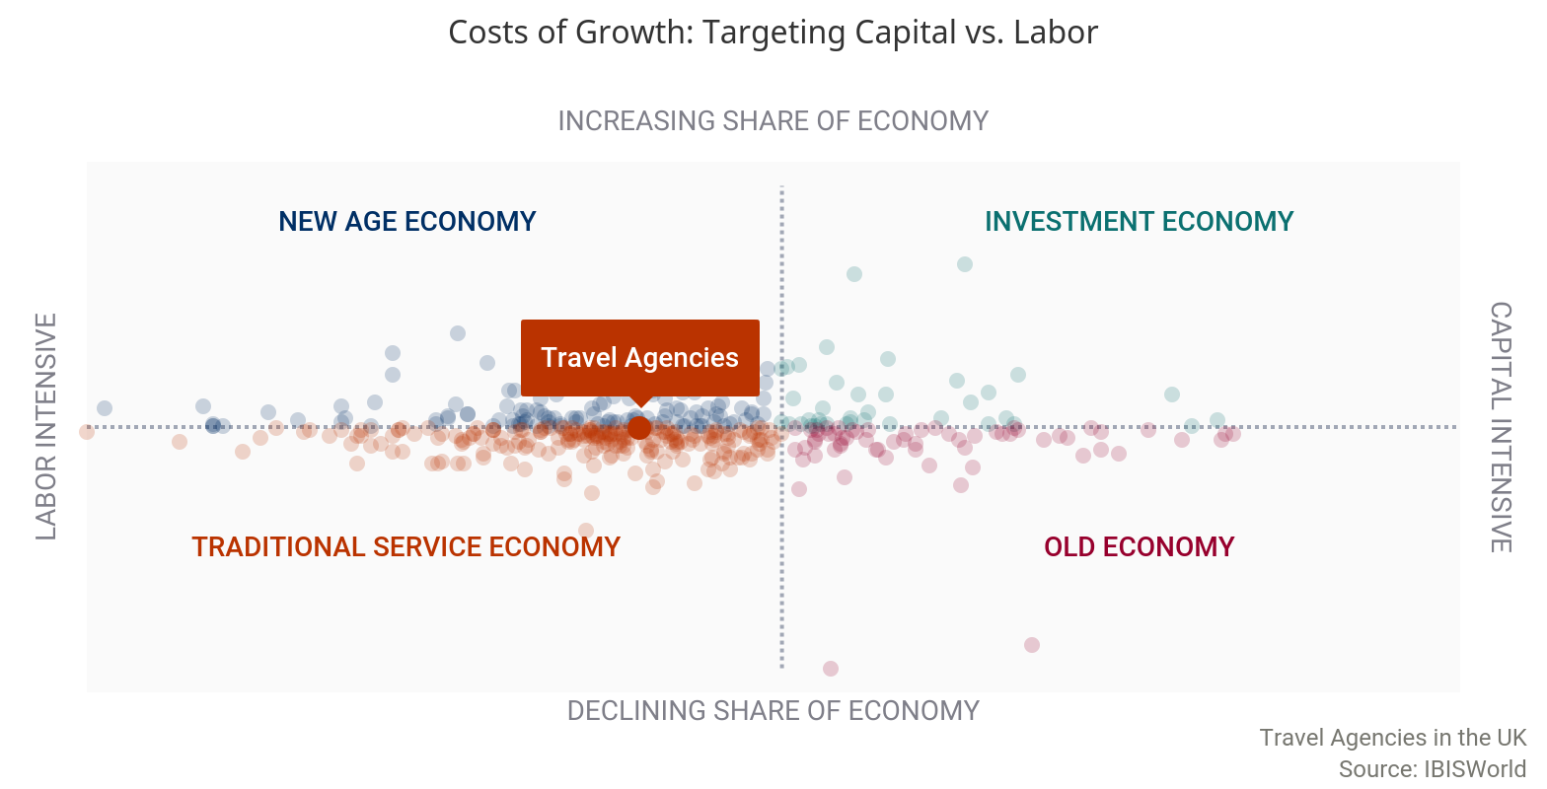
Capital Intensity | The level of capital intensity is Medium
  The industry is moderately labour intensive due to the high level of personal contact with customers and the importance of agents knowing travel products well so they can market them to customers effectively. Computerised reservation systems (CRS), or global distribution systems continue to remain a feature of the industry, as does ticketless travel. Despite increasing investment in technology, labour costs have increased over recent years due to changes to the minimum wage. The National Living Wage was introduced in April 2016 and has increased in the years since. In 2020-21, for every £1.00 invested in capital, an expected £6.18 is spent on wages.  CRSs allow for more effective sales of high retail margin travel insurance policies, the electronic processing of transactions, electronic vouchering, electronic transfer of funds from a customer to an agency and electronic settling of accounts. These systems are also linked into operators' accounting and information storage and retrieval systems. Email, telemarketing and internet facilities are fairly common in the industry nowadays and are integrated with the above systems. The general availability of these CRS to business clients and the general public has been growing. The programmes automatically calculate payments and confirm availability, bookings and reservations.  While a significant proportion of sales also now involve credit or debit cards, traveller's cheques are still sometimes used when travelling overseas and these are sold through agencies. The major online travel operator in the industry is Expedia. Expedia and its online competitors are forecast to continue to grow strongly through the use of online technology and systems. Slow increases in employment and associated wage expenses are expected to take place over the next five years, although rising capital investment is expected to push capital intensity upwards. Consequently, the industry is anticipated to become more capital intensive, although it is expected to remain at a moderate level. | 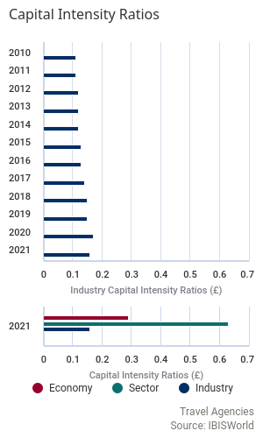
Technology & Systems | Potential Disruptive Innovation: Factors Driving Threat of Change
Level |  | Factor | Disruptive Effect | Description
 | High | Rate of Innovation | Likely | A ranked measure for the number of patents assigned to an industry. A faster rate of new patent additions to the industry increases the likelihood of a disruptive innovation occurring.
 | Very High | Innovation Concentration | Very Likely | A measure for the mix of patent classes assigned to the industry. A greater concentration of patents in one area increases the likelihood of technological disruption of incumbent operators.
 | High | Ease of Entry | Likely | A qualitative measure of barriers to entry. Fewer barriers to entry increases the likelihood that new entrants can disrupt incumbents by putting new technologies to use.
 | Very High | Rate of Entry | Very Likely | Annualized growth in the number of enterprises in the industry, ranked against all other industries. A greater intensity of companies entering an industry increases the pool of potential disruptors.
 | Low | Market Concentration | Unlikely | A ranked measure of the largest core market for the industry. Concentrated core markets present a low-end market or new market entry point for disruptive technologies to capture market share.

The industry has a high rate of new patent technologies combined with a concentrated focus of patent types. New technology entering the industry increases the likelihood of discontinuous innovations. A concentrated focus of technologies can suggest that the industry itself is focused on sustaining innovations, which may disincentivize incumbents from leveraging non-core technologies.
This technology trend is underscored by structural factors that support new entrants. An accommodative structure can create a situation where small entrants can focus on less profitable albeit innovative industry entry points. Or, large operators in other industries can leverage expertise in other areas to enter the industry from a new angle.
Major market segments for industry operators are relatively diversified. The spread of market segments suggests that there are limited entry points other than those already served my incumbent operators.
The most recent technology disruption in the industry of travel agencies is the digital technology and the use of online automated services or applications.

Such applications are used to automatically find the customers suitable travel packages according to their needs. This digital transformation entails the use of chatbots which enhances customer experience. Artificial intelligence simplifies travel decisions and shortens the time of purchase.
In addition to that, travel agency in the form of mobile applications reduces the need to contact a travel agent office as customers self-modify and personalise their options. Business which lag behind this transformation and which show inability to leverage technology are affected negatively. Such business may go out of the market, or reduce their workforce to cope with the competition.
The level of technology change is Medium
The industry displays a medium level of technological change.

The emergence of widespread internet use and the increasing adoption of IT and telecommunications by both consumers and businesses has led many firms to shift their focus online in order to cut costs, as maintaining a physical store is more expensive for operators. However, this has also shifted demand away from the industry as online access to multiple booking systems enables travellers to do self-service booking independently of an agency.
Technological advancements surrounding the quality and types of communications platforms have also affected the industry. Video communication technology can personalise the experience of booking a holiday for consumers while enabling firms to forgo investments in physical stores. The introduction of Voice over Internet Protocol (VoIP), is expected to have significantly lowered costs for operators. VoIP enables travel centre agents to send or receive calls over the internet as opposed to using a standard landline connection. Contacting customers in this way is substantially cheaper than using landlines, though the line quality is not as reliable. In addition, VoIP is primarily used by operators to contact customers domestically, while using VoIP to make and receive international calls is expected to be very expensive. This is relevant to the industry as travel agents often have to contact overseas tour operators, accommodation providers and other upstream industries, although in this case operators may choose to conduct communications via email.
Social media has become an important tool in marketing and communications in the industry, as businesses are able to build brand awareness and customer relationships. Based on findings from Facebook's IQ 2017 Study, 61% of all Instagram users say that they use the app to plan their trips to new places. VisitScotland opened the first ever Instagram Travel Agency in 2017, allowing customers to build their holidays to Scotland based entirely around other people's Instagram photos. Virtual reality has also become a promising tech trend for travel agencies in terms of marketing, because it allows them to digitally transport customers to a virtual recreation of a specific place. This affords hotels the opportunity to showcase their rooms, reception areas and even local tourist hotspots on their website, in order to encourage bookings. Artificial intelligence is also used as a marketing tool by sorting through data and drawing conclusions about trends associated with customer satisfaction and which customers would be most receptive to targeted deals.
Revenue Volatility | The level of volatility is Medium
 | 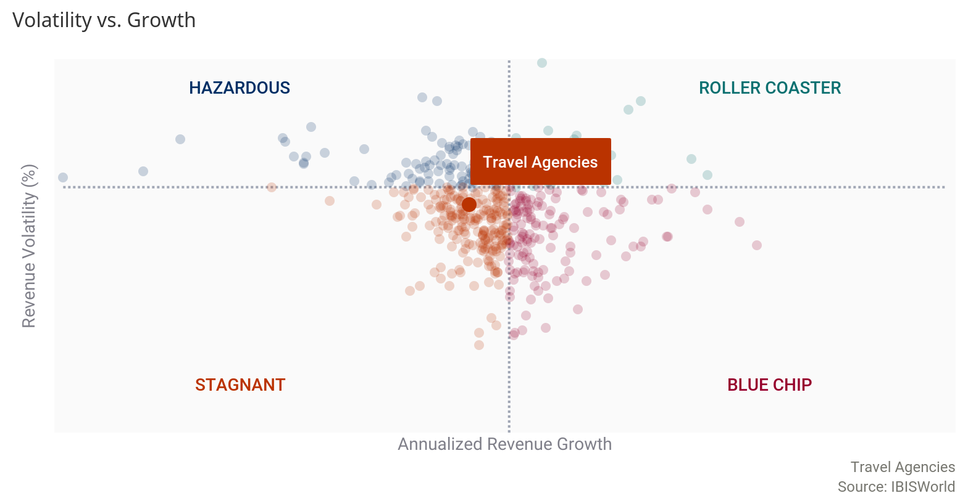
Over the five-year period through 2020-21, revenue volatility is expected to be moderate.

Revenue volatility was at a moderate level in the base year of the period due to isolated events such as the terrorist attack in Tunisia in June 2015, and the European migrant crisis in 2015, leading to massive disruption to the industry.
Fluctuations in revenue are often caused by changes in the wider economy, in particular factors affecting real household disposable income and consumer confidence. If the economy is growing, job opportunities are likely to rise at a greater rate than the number of people looking for work. Consequently, wages are likely to rise, increasing levels of real household disposable income. When consumers have more money in their pockets, they are likely to go on holiday more often. In addition, the types of holidays they choose are generally more expensive, contributing to rising to industry revenue. Consumer confidence levels are expected to have a similar effect, increasing in times of economic prosperity, leading consumers to spend more on industry services.
Despite declining economic conditions after the EU referendum in June 2016, revenue remained stable towards the end of the period. The weak pound did not initially deter people from going on holiday, though according to the Association of British Travel Agents, the average number of holidays taken per person in the United Kingdom fell from 3.8 in 2017 to 3.4 in 2018. This led to a large drop in revenue growth in 2018-19.
Industry revenue is expected to decline over the two years through 2020-21, as a result of the global COVID-19 pandemic, which temporarily put a halt to all but essential foreign travel, essentially negating the need for the industry's services. Since July 2020, some countries have been placed on a travel corridor list, meaning individuals are allowed to come into the United Kingdom from these destinations without having to undergo a 14-day quarantine period. However, the UK government is continually updating the list, meaning many consumers are opting to avoid international travel until the situation becomes more certain, in order to fully avoid the quarantine period. This is expected to weigh further on industry revenue in the second half of the current year.
Regulation & Policy | The level of regulation is Medium and the trend is Steady  Industry firms that sell flights must comply with the Civil Aviation Authority's Air Traffic Organisers License (ATOL) Regulations.  If a travel company with an ATOL ceases trading, the ATOL scheme protects customers who had booked holidays with the firm. It ensures that they do not get stranded abroad or lose money. In addition, companies that provide in-flight food must also comply with the policy and regulations of the Food Standards Agency in order to protect the health and safety of consumers.  Package holidays are defined as comprising of two or more of the following: accommodation, transport, car rental, and other tourist services such as a tour guide or a trip to a historical attraction. When selling package holidays, operators must adhere to the new Package Travel Regulations, which came into force in July 2018 and provide financial guarantees and protection to consumers booking such holidays. It is illegal for travel agencies to omit doing this, as failure to do so leaves the consumer financially unprotected. In 2015, the scope of the directive was expanded to cover approximately 120 million consumers that book other forms of combined travel, such as those that are selected by the consumer themselves.  In the wake of the COVID-19 outbreak, the UK travel sector is calling on the government to make immediate changes to the package travel regulations. Under the existing regulations tour operators are obliged to offer a full refund if elements of the holiday cannot be provided. The Association of British Travel Agents (ABTA) is asking for an emergency government consumer hardship fund to fulfil refund payments; and is also requesting that credits should be allowed as an alternative to cash refunds. In addition, it is calling for the current 14-day window for refund payments to be removed.  Compliance costs are not expected to be especially significant for industry operators. However, the failure to protect customers and adhere to relevant legal obligations is likely to incur significant charges.  Although operators do not need any qualifications to set up as a travel agent, their chances of success are greatly increased if they join a trade association, as it boosts reputation as a trustworthy operator. The most widely recognised trade association is the ABTA, although this is also the most expensive and therefore aimed less at start-ups than the Travel Trust Association or the Global Travel Group. These associations have regularly updated codes of conduct and keep operators up to date with changing regulations, giving customers and the operator protection.
Industry Assistance | The level of industry assistance is Low and the trend is Steady  The industry does not receive any direct assistance from the government in terms of grants, funds or subsidies, but travel agencies are likely to benefit indirectly from other government funds.In 2012, the government launched the GREAT campaign to encourage tourists to visit the United Kingdom and, as of May 2015, the government had invested £22 million into the campaign.  gn. In September 2018 it was reported that the campaign has far exceeded expectations, resulting in a £3.4 billion economic return to date, in what the government claims is its most successful international campaign ever. The GREAT brand is valued at £271 million, according to a recent independent assessment by valuation experts Brand Finance. The campaign involved the promotion of the British countryside, culture, heritage, creativity, innovation, knowledge, shopping, sport, music and technology.  In order to further boost tourism across the United Kingdom, in August 2016, the government created the Discover England fund, investing £40 million in projects and organisations in different areas of the United Kingdom to attract tourism outside of London. Operators may benefit indirectly from this through an increase in demand for domestic tourism.  The industry is also expected to receive indirect assistance through the European Bank for Reconstruction and Development Trade Facilitation Programme which can guarantee any trade transaction to, from and between the countries of operations. This is expected to benefit industry operators, as organising overseas travel requires international transactions. It is unclear whether Britain's exit from the European Union will have an impact on operators' access to the programme.  There are multiple industry associations which offer insurance to operators as well as advice and guidance in order to support high service standards, ensure health and safety regulations are met, and promote responsible tourism at home and abroad. The most widely recognised trade association is the Association of British Travel Agents; the Travel Trust Association and the Global Travel Group are examples of smaller recognised associations.

Key Statistics

Industry Data
Year | Revenue  (£m) | IVA  (£m) | Establishments  (Units) | Enterprises  (Units) | Employment  (Units) | Exports  (£m) | Imports  (£m) | Wages  (£m) | Domestic  Demand (£m)
2011-12 | 30,314 | 4,082 | 7,271 | 3,847 | 60,947 | N/A | N/A | 2,311 | N/A
2012-13 | 29,517 | 3,800 | 7,426 | 3,794 | 58,835 | N/A | N/A | 2,168 | N/A
2013-14 | 29,551 | 4,000 | 7,214 | 3,925 | 57,991 | N/A | N/A | 2,139 | N/A
2014-15 | 30,746 | 4,037 | 7,075 | 4,070 | 55,284 | N/A | N/A | 2,070 | N/A
2015-16 | 31,701 | 4,364 | 7,332 | 4,414 | 56,801 | N/A | N/A | 2,213 | N/A
2016-17 | 32,499 | 4,612 | 7,511 | 4,690 | 57,190 | N/A | N/A | 2,272 | N/A
2017-18 | 35,015 | 4,762 | 7,258 | 4,565 | 58,449 | N/A | N/A | 2,311 | N/A
2018-19 | 35,038 | 4,421 | 7,402 | 4,619 | 60,027 | N/A | N/A | 2,319 | N/A
2019-20 | 34,518 | 4,204 | 7,435 | 4,596 | 59,367 | N/A | N/A | 2,271 | N/A
2020-21 | 27,485 | 2,697 | 6,982 | 4,407 | 52,481 | N/A | N/A | 1,872 | N/A
2021-22 | 31,388 | 3,127 | 7,142 | 4,518 | 56,626 | N/A | N/A | 2,091 | N/A
2022-23 | 32,549 | 4,071 | 7,221 | 4,576 | 57,533 | N/A | N/A | 2,151 | N/A
2023-24 | 33,363 | 4,358 | 7,286 | 4,686 | 57,935 | N/A | N/A | 2,189 | N/A
2024-25 | 34,097 | 4,510 | 7,432 | 4,789 | 58,457 | N/A | N/A | 2,226 | N/A
2025-26 | 34,711 | 4,761 | 7,543 | 4,832 | 59,217 | N/A | N/A | 2,262 | N/A

Annual Change
Year | Revenue  (%) | IVA  (%) | Establishments  (%) | Enterprises  (%) | Employment  (%) | Exports  (%) | Imports  (%) | Wages  (%) | Domestic  Demand (%)
2011-12 | 14.0 | 14.4 | -3.47 | 0.49 | -0.13 | N/A | N/A | 6.23 | N/A
2012-13 | -2.63 | -6.90 | 2.13 | -1.38 | -3.47 | N/A | N/A | -6.17 | N/A
2013-14 | 0.11 | 5.25 | -2.86 | 3.45 | -1.44 | N/A | N/A | -1.37 | N/A
2014-15 | 4.04 | 0.91 | -1.93 | 3.69 | -4.67 | N/A | N/A | -3.20 | N/A
2015-16 | 3.10 | 8.11 | 3.63 | 8.45 | 2.74 | N/A | N/A | 6.87 | N/A
2016-17 | 2.51 | 5.66 | 2.44 | 6.25 | 0.68 | N/A | N/A | 2.66 | N/A
2017-18 | 7.74 | 3.25 | -3.37 | -2.67 | 2.20 | N/A | N/A | 1.71 | N/A
2018-19 | 0.06 | -7.16 | 1.98 | 1.18 | 2.69 | N/A | N/A | 0.35 | N/A
2019-20 | -1.49 | -4.92 | 0.44 | -0.50 | -1.10 | N/A | N/A | -2.07 | N/A
2020-21 | -20.4 | -35.8 | -6.10 | -4.12 | -11.6 | N/A | N/A | -17.6 | N/A
2021-22 | 14.2 | 15.9 | 2.29 | 2.51 | 7.89 | N/A | N/A | 11.7 | N/A
2022-23 | 3.70 | 30.2 | 1.10 | 1.28 | 1.60 | N/A | N/A | 2.85 | N/A
2023-24 | 2.49 | 7.03 | 0.90 | 2.40 | 0.69 | N/A | N/A | 1.78 | N/A
2024-25 | 2.20 | 3.50 | 2.00 | 2.19 | 0.90 | N/A | N/A | 1.68 | N/A
2025-26 | 1.80 | 5.54 | 1.49 | 0.89 | 1.30 | N/A | N/A | 1.59 | N/A

Key Ratios
Year | IVA/Revenue  (%) | Imports/  Demand  (%) | Exports/  Revenue  (%) | Revenue per  Employee  (£'000) | Wages/  Revenue  (%) | Employees per  estab.  (Units) | Average Wage (£)
2011-12 | 13.5 | N/A | N/A | 497 | 7.62 | 8.38 | 37,917
2012-13 | 12.9 | N/A | N/A | 502 | 7.35 | 7.92 | 36,857
2013-14 | 13.5 | N/A | N/A | 510 | 7.24 | 8.04 | 36,882
2014-15 | 13.1 | N/A | N/A | 556 | 6.73 | 7.81 | 37,452
2015-16 | 13.8 | N/A | N/A | 558 | 6.98 | 7.75 | 38,959
2016-17 | 14.2 | N/A | N/A | 568 | 6.99 | 7.61 | 39,725
2017-18 | 13.6 | N/A | N/A | 599 | 6.60 | 8.05 | 39,535
2018-19 | 12.6 | N/A | N/A | 584 | 6.62 | 8.11 | 38,634
2019-20 | 12.2 | N/A | N/A | 581 | 6.58 | 7.98 | 38,255
2020-21 | 9.81 | N/A | N/A | 524 | 6.81 | 7.52 | 35,678
2021-22 | 9.96 | N/A | N/A | 554 | 6.66 | 7.93 | 36,928
2022-23 | 12.5 | N/A | N/A | 566 | 6.61 | 7.97 | 37,386
2023-24 | 13.1 | N/A | N/A | 576 | 6.56 | 7.95 | 37,787
2024-25 | 13.2 | N/A | N/A | 583 | 6.53 | 7.87 | 38,079
2025-26 | 13.7 | N/A | N/A | 586 | 6.52 | 7.85 | 38,192

Additional Resources
Additional Resources | Eye for Travel  http://www.eyefortravel.com  VisitBritain  http://www.visitbritain.org  Travel Weekly  http://www.travelweekly.co.uk  Association of British Travel Agents  http://www.abta.com

Industry Jargon | AMADEUS  A global travel distribution system used by UK travel agents.  GLOBAL DISTRIBUTION SYSTEM  A computerised reservation system used by travel agents to help them with information, bookings, reservations and payments.  STAYCATION  A vacation spent in one's home country rather than abroad, or one spent at home and involving day trips to local attractions.

Glossary | BARRIERS TO ENTRY  High barriers to entry mean that new companies struggle to enter an industry, while low barriers mean it is easy for new companies to enter an industry.  CAPITAL INTENSITY  Compares the amount of money spent on capital (plant, machinery and equipment) with that spent on labour. IBISWorld uses the ratio of depreciation to wages as a proxy for capital intensity. High capital intensity is more than £0.333 of capital to £1 of labour; medium is £0.125 to £0.333 of capital to £1 of labour; low is less than £0.125 of capital for every £1 of labour.  CONSTANT PRICES  The pound figures in the Key Statistics table, including forecasts, are adjusted for inflation using the current year (i.e. year published) as the base year. This removes the impact of changes in the purchasing power of the pound, leaving only the 'real' growth or decline in industry metrics. The inflation adjustments in IBISWorld’s reports are made using the Office for National Statistics' implicit GDP price deflator.  DOMESTIC DEMAND  Spending on industry goods and services within the UK, regardless of their country of origin. It is derived by adding imports to industry revenue, and then subtracting exports.  EMPLOYMENT  The number of permanent, part-time, temporary and casual employees, working proprietors, partners, managers and executives within the industry.  ENTERPRISE  A division that is separately managed and keeps management accounts. Each enterprise consists of one or more establishments that are under common ownership or control.  ESTABLISHMENT  The smallest type of accounting unit within an enterprise, an establishment is a single physical location where business is conducted or where services or industrial operations are performed. Multiple establishments under common control make up an enterprise.  EXPORTS  Total value of industry goods and services sold by UK companies to customers abroad.  IMPORTS  Total value of industry goods and services brought in from foreign countries to be sold in the UK.  INDUSTRY CONCENTRATION  An indicator of the dominance of the top four players in an industry. Concentration is considered high if the top players account for more than 70% of industry revenue. Medium is 40% to 70% of industry revenue. Low is less than 40%.  INDUSTRY REVENUE  The total sales of industry goods and services (exclusive of excise and sales tax); subsidies on production; all other operating income from outside the firm (such as commission income, repair and service income, and rent, leasing and hiring income); and capital work done by rental or lease. Receipts from interest royalties, dividends and the sale of fixed tangible assets are excluded.  INDUSTRY VALUE ADDED (IVA)  The market value of goods and services produced by the industry minus the cost of goods and services used in production. IVA is also described as the industry's contribution to GDP, or profit plus wages and depreciation.  INTERNATIONAL TRADE  The level of international trade is determined by ratios of exports to revenue and imports to domestic demand. For exports/revenue: low is less than 5%; medium is 5% to 20%; and high is more than 20%. Imports/domestic demand: low is less than 5%; medium is 5% to 35%; and high is more than 35%.  LIFE CYCLE  All industries go through periods of growth, maturity and decline. IBISWorld determines an industry's life cycle by considering its growth rate (measured by IVA) compared with GDP; the growth rate of the number of establishments; the amount of change the industry's products are undergoing; the rate of technological change; and the level of customer acceptance of industry products and services.  NONEMPLOYING ESTABLISHMENT  Businesses with no paid employment or payroll, also known as nonemployers. These are mostly set up by self-employed individuals.  PROFIT  IBISWorld uses earnings before interest and tax (EBIT) as an indicator of a company’s profitability. It is calculated as revenue minus expenses, excluding interest and tax.  VOLATILITY  The level of volatility is determined by averaging the absolute change in revenue in each of the past five years. Volatility levels: very high is more than ±20%; high volatility is ±10% to ±20%; moderate volatility is ±3% to ±10%; and low volatility is less than ±3%.  WAGES  The gross total wages and salaries of all employees in the industry. The cost of benefits is also included in this figure

IBISWorld helps you find the industry information you need – fast.
With our trusted research covering thousands of global industries, you’ll get a quick and intelligent overview of any industry so you can get up to speed in minutes. In every report, you’ll find actionable insights, comprehensive data and in-depth analysis to help you make smarter, faster business decisions. If you’re not yet a member of IBISWorld, contact us at 020 3008 6568 or info@ibisworld.co.uk to learn more.
DISCLAIMER
This product has been supplied by IBISWorld Ltd. (‘IBISWorld’) solely for use by its authorised licensees strictly in accordance with their licence agreements with IBISWorld. IBISWorld makes no representation to any other person with regard to the completeness or accuracy of the data or information contained herein, and it accepts no responsibility and disclaims all liability (save for liability that cannot be lawfully disclaimed) for loss or damage whatsoever suffered or incurred by any other person resulting from the use of, or reliance upon, the data or information contained herein. Copyright in this publication is owned by IBISWorld Ltd. The publication is sold on the basis that the purchaser agrees not to copy the material contained within it for other than the purchaser’s own purposes. In the event that the purchaser uses or quotes from the material in this publication – in papers, reports or opinions prepared for any other person – it is agreed that it will be sourced to IBISWorld Ltd

Copyright 2020 IBISWorld Ltd.



